The Law Reform Commission of Hong Kong

Sub-Committee on
Description of Flats on Sale

Consultative Document

The Law Reform Commission
of Hong Kong

Sub-Committee on
Description of Flats on Sale

Consultative Document
_________________________________

CONTENTS

Chapter | Page
Introduction and overview | 1
Terms of reference | 1
Sub-committee membership | 1
Meetings | 2
Scope of deliberations | 2
Uncompleted residential property | 3
Our recommendation on the definition of “uncompleted  residential property” | 3
“Consent” and “Non-Consent” schemes | 3
(i) Consent scheme | 4
(ii) Non-consent scheme | 4
Glossary of terms | 4
Consultative document | 4
1. Measurement of floor area | 6
Introduction | 6
Gross floor area | 6
Two methods of measuring gross floor area | 6
Our recommendations on gross floor area | 8
Saleable area | 9
Our recommendations on saleable area | 10
2. Floor plan | 11
Introduction | 11
Information in floor plans | 11
Internal areas of upper and lower floors | 12
Standard term regarding variation of floor plans | 12
Load bearing walls | 13
Special features within units | 13
Our recommendations on floor plans | 13
3. Fittings and finishes | 15
Introduction | 15
Problems with description of fittings and finishes | 16
Land Office Circular Memorandum No. 101 | 16
Supply of flush water/sewage treatment plant | 17
Our recommendations on fittings and finishes | 17
Discrepancies between languages | 17
Our recommendation on language discrepancies | 18
Mock-up flats | 18
Our recommendations on mock-up flats | 18
4. Location and layout plans | 19
(or site and development plans)
Introduction | 19
LOCM 101 | 19
The Real Estate Developers Association | 20
Our view on REDA’s objections | 20
Uses of land within the development and of adjoining land | 20
Our recommendations on location plans | 21
Our recommendations on layout plans | 21
Our recommendations on uses of land | 21
5. Date of completion | 23
The importance of the date of completion | 23
Current problems with date of completion | 23
The expected dates of issue of the Occupation Permit and  Certificate of Compliance | 24
The construction completion date as stated in the ASP | 24
Our recommendations on dates of completion | 25
6. Charges levied on transfer of title to sub-purchasers | 26
Means of transfer to sub-purchasers | 26
Disclosure of charges on transfer | 26
Our recommendation on transfer to sub-purchasers | 27
7. Financing arrangements | 28
Information on mortgage facilities | 28
Developers providing mortgage facilities | 28
Our recommendations on financing arrangements | 28
Interest chargeable for late payment of purchase price | 29
Our recommendation on interest on late payments | 29
8. Preliminary agreement for sale and purchase | 30
Introduction | 30
Preliminary Agreement under the Consent Scheme | 30
Our recommendations on Consent Scheme preliminary agreements | 31
Preliminary Agreements outside the Consent Scheme | 32
Our recommendations on preliminary agreements not governed by  the Consent Scheme | 33
- Right of inspection prior to completion of  transaction and defect liability period | 34
The current practice | 34
Should there be a right of inspection prior to completion? | 34
The advantages | 34
The disadvantages | 35
Conclusion | 35
Defect Liability Period | 36
Our recommendation on Defect Liability Period | 36
10. Deed of mutual covenant | 37
Introduction | 37
Salient points | 37
Subsequent changes | 38
Chinese translations | 38
Private slope maintenance | 38
Continuing financial obligations | 39
Our recommendations on DMC | 39
11. Conditions of the land lease | 41
Introduction | 41
User restrictions | 41
Duration of the land lease | 42
Special lease conditions | 42
Our recommendations on conditions of land lease | 43
12. Prices and number of units for sale and internal sale | 44
Prices | 44
Our recommendations on price lists | 45
Number of units offered for sale | 45
Internal sale through private placement | 45
Buy-back arrangements | 46
Our recommendations on number of units for sale and internal sale | 46
13. Miscellaneous information | 47
Introduction | 47
Name of contractors and authorized persons | 47
Our recommendation on names of contractors and Authorized  Persons | 48
Responsibility for transaction fee | 48
Our recommendations on transactions fee | 48
Date of printing of sales brochure | 49
Our recommendations on date of sales brochure | 49
Supplementary charges upon taking possession | 49
Our recommendations on supplementary charges | 50
14. Availability of sales brochures | 51
The availability of sales brochures | 51
Advertisements other than sales brochures | 52
Our recommendations on sales brochures and other forms of  publicity | 53
15. Enforcement of the recommendations | 54
Means of enforcement | 54
Self-regulation | 54
Administrative measures | 54
Legislation | 55
Features of the proposed legislation | 55
(a) Penalty | 55
(b) Civil remedies | 55
(c) Definition of developer | 55
Our recommendations on means of enforcement | 56
16 Summary of recommendations | 57
Mock-up sales brochure and mock-up price list | 57
Summary of recommendations | 57
Definition of “uncompleted residential property” | 57
Gross floor area | 57
Saleable area | 58
Floor plans | 58
Fittings and finishes | 59
Language discrepancies in specifications of fittings and finishes | 60
Mock-up flats | 60
Location plans | 60
Layout plans | 60
Uses of land | 60
Dates of completion | 61
Transfer to sub-purchasers | 61
Financing arrangements | 61
Interest on late payments | 61
Consent Scheme preliminary agreements | 62
Preliminary agreements not governed by the Consent Scheme | 62
Defect Liability Period | 62
Deed of Mutual Covenant | 62
Conditions of land lease | 63
Price lists | 63
Number of units for sale and internal sale | 63
Contractors and authorized persons | 63
Transaction fee | 63
Date of sales brochure | 64
Supplementary charges | 64
Sales brochure and other forms of publicity | 64
Means of enforcement of recommendations | 65
17. Some observations | 67
Non-Consent preliminary agreements | 67
Warranties made to the developer by the contractor | 67
Defect Liability Period | 68
Private slope maintenance | 68
Appendix I | 69
Glossary of Terms | 69
Appendix II | 74
Mock-Up Sales Brochure | 75
Appendix III | 102
Mock-Up Price List | 103
Appendix IV | 107
Land Office Circular Memorandum No. 101 | 108

Introduction and overview

__________________________________

Terms of reference

1. In June 1992, the then Acting Attorney General and the Acting Chief Justice made the following reference to the Law Reform Commission:

“Should the law governing the protection of prospective purchasers and purchasers of uncompleted residential property in relation to inadequate or misleading sales information or particulars be changed and, if so, in what way?”

Sub-committee membership

2. In November 1992 the Law Reform Commission appointed a sub-committee under the chairmanship of Professor Derek Roebuck to consider the above terms of reference and to make proposals to the Law Reform Commission for reform. The membership of the sub-committee was:

Professor Derek Roebuck  (Chairman) | Dean of Faculty of Law,  City Polytechnic of Hong Kong  Solicitor
Mr Tom Berry | Principal Solicitor,  Lands Department
Ms CHEUNG Siu-hing  (from 5.1.1993 to 1.12.1993) | Principal Assistant Secretary  (Lands),  Planning, Environment and Lands Branch,  Government Secretariat
Ms Audrey EU Yuet-mee, QC | Queen’s Counsel
Mr Andrew LEE King-fun | Architect, Principal Partner of  Andrew LEE King-fun and Associates
Mr Bowen LEUNG Po-wing  (up to 30.11.1992) | Deputy Secretary (Lands and Planning),  Planning, Environment and Lands Branch,  Government Secretariat
Mr Alasdair Morrison | Managing Director,  Hong Kong Land Group Limited
Mr Patrick Sheehan | Lecturer in Law,  University of Hong Kong,  Solicitor
Mr William SHIU Wai-chuen  (since 19.11.1993) | Principal Assistant Secretary  (Housing Policy),  Planning, Environment and Lands Branch,  Government Secretariat
Mr Marco WU Moon-hoi | Assistant Director of Housing Department

3. Mr Thomas LEUNG Moon-keung, Senior Crown Counsel acted as the Secretary to the sub-committee.

Meetings

4. We (the sub-committee) met for the first time on 11 December 1992 and, between then and 5 November 1993, have held a total of 17 meetings.

Scope of deliberations

5. As our terms of reference are confined to uncompleted residential property, we have not extended our deliberations to commercial or industrial buildings, nor residential properties which are completed at the time of sale.

6. It is however common to find buildings with mixed residential and commercial units in Hong Kong. We have therefore also considered uncompleted units in such buildings, though we have directed our minds to the residential components only.

7. In the case of uncompleted residential properties, the principal sales descriptions are made through the issue of sales brochures and price lists. We have therefore considered whether there is a need to improve the quality and reliability of sales brochures and price lists for the better protection of purchasers and, if so, what the best means are to achieve that aim.

8. In the course of our deliberations, we have referred to various documents for factual background and helpful ideas, including a report published by the Consumer Council in October 1991, A Study on the Disclosure of Information to Prospective Purchasers of Uncompleted Units ("Consumer Council report").

Uncompleted residential property

9. Our terms of reference refer to "uncompleted residential property".

10. We consider that it will suffice simply to define “uncompleted residential property” as residential units for which the Occupation Permit has yet to be issued by the Building Authority under the Buildings Ordinance (Cap. 123). This definition covers properties which are in the Consent Scheme and also those which are not. (The Consent and Non-Consent Schemes are explained later in this chapter.)

11. We understand that a Completion Certificate is issued in place of an Occupation Permit for flats in the Housing Authority’s Home Ownership Scheme ("HOS"). It is, in our view, unnecessary to extend the definition to cover Completion Certificates and thereby take in uncompleted HOS flats. We are not aware of any complaints about the accuracy and sufficiency of details in HOS sales brochures and we have based much of our mock-up sales brochure (in Appendix I) on HOS brochures. We believe that the Housing Authority will take our recommendations into account in drawing up future HOS brochures.

12. On the other hand, there is no Occupation Permit for exempted houses in the New Territories. As most developments need an Occupation Permit, we hold the view that it will be best to adopt the Occupation Permit for our definition. Exempted houses should receive separate consideration.

Our recommendation on the definition of "uncompleted residential property"

13. We recommend that "uncompleted residential property" should refer to residential units for which the Occupation Permit has yet to be issued by the Building Authority under the Buildings Ordinance. We further recommend that this definition should be suitably modified in the case of exempted houses in the New Territories.

"Consent" and "Non-Consent" Schemes

14. There are two schemes for uncompleted buildings: the "Consent Scheme" and the "Non-Consent Scheme". As we shall make frequent references to these two schemes later in this report, it will be convenient to outline the schemes at this point.

(i) Consent Scheme

15. The Consent Scheme applies to the development of lots where the Government Leases stipulate that the prior consent of the Director of Lands must be obtained before the sale or other disposal of uncompleted units to a purchaser can be made. It also covers situations where an Exclusion Order made under the Landlord and Tenant (Consolidation) Ordinance (Cap. 7) contains clauses prohibiting the owners from entering into agreements for the sale of uncompleted units without the Director of Lands’ prior consent.

16. The Consent Scheme previously administered by the Registrar General (Land Officer) is now the responsibility of the Legal Advisory and Conveyancing Office of the Lands Department following the dissolution of the Registrar General’s Department and the transfer of its various functions to other Government officers. The rules for granting consent are set out in Legal Advisory and Conveyancing Office Circular Memoranda issued from time to time by the Director of Lands (or Land Office Circular Memoranda previously issued by the Registrar General). The conditions for granting consent can therefore be varied to meet changing needs to protect purchasers of uncompleted units.

(ii) Non-Consent Scheme

17. The Non-Consent Scheme refers to property developments where there are no lease conditions stipulating that prior consent of the Director of Lands is required for the sale of uncompleted units. In these cases, if the same solicitor acts for both the vendor and purchasers, the solicitor is required to comply with Rule 5C of the Solicitors (Practice) Rules and other Practice Directions issued by the Law Society of Hong Kong and to use a standard form of Agreement for Sale and Purchase ("ASP") which closely follows that used in the Consent Scheme.

Glossary of terms

18. To help readers to understand the contents of this report, there is a glossary of terms at Appendix I.

Consultative document

19. This is a consultative document which contains our interim report. In it we have set out our interim recommendations.

20. The purpose of circulating this consultative document is to invite property developers, agents, lawyers, members of the public and other interested parties to express their views on the matters raised and recommendations made. It must be emphasized that this is only a consultative document and not the final report of the sub-committee. We shall present our final report to the Law Reform Commission after taking into account views on consultation.

21. Written comments should be sent to the Secretary, Sub-committee on Description of Flats on Sale, Law Reform Commission, 4/F, High Block, Queensway Government Offices, 66 Queensway, Hong Kong on or before 30 June 1994.

Chapter 1

Measurement of floor area

__________________________________

Introduction

1.1 Accurate and adequate indication of the floor area of the unit is of paramount importance to purchasers. Without correct information on the floor area, purchasers cannot make a sound decision whether the unit will meet their specific needs and means.

1.2 At present there is no legal requirement that the floor areas of a unit be disclosed in the sales literature.

Gross floor area

1.3 Property developers invariably state in the sales literature the gross floor area of the units, yet there is no standard definition of gross floor area. The absence of a standardized method of measuring gross floor area makes possible arbitrary measurement methods which give misleading information to purchasers.

1.4 In Hong Kong purchasers are used to thinking in terms of gross floor area when they compare the prices of different properties. When people say a particular property costs so much per square foot, they usually refer to the gross floor area. A glance through the property pages of the major local newspapers will reveal that gross floor area is the measurement method commonly indicated by developers and private vendors.

1.5 Hence, as a comprehensive guide for home-buyers who are used to thinking in terms of gross floor area, we are of the view that there is merit in keeping the definition of the term gross floor area consistent throughout the property market. To achieve this aim the definition should be standard for all concerned parties, including developers, agencies, other professional organisations and government departments.

Two methods of measuring gross floor area

1.6 The gross floor area of a domestic unit commonly refers to the saleable area plus a share of the covered common areas. The confusion usually sterns from the different ways in which common areas are defined.

1.7 We have considered two current methods of calculating the gross floor area. The first method is commonly used by developers and is more or less in line with the definition suggested in the Consumer Council report. In that definition, "common area" includes all circulation areas and ancillary facilities such as pump rooms, transformer rooms and lift machine rooms.

1.8 A second method of measuring gross floor area is adopted by the Building Authority under the Buildings Ordinance in Reg. 23(3) of the Building (Planning) Regulations for approval of building plans for all building developments in Hong Kong.

1.9 Reg. 23(3) of the Building (Planning) Regulations provides that:

“(a) Subject to sub-paragraph (B), for the purposes of regulations 19, 20, 21 and 22, the gross floor area of a building shall be the area contained within the external walls of the building measured at each floor level (including any floor below the level of the ground), together with the area of each balcony in the building, which shall be calculated from the overall dimensions of the balcony (including the thickness of the sides thereof), and the thickness of the external walls of the building.

(b) In determining the gross floor area for the purposes of regulations 20, 21 and 22, the Building Authority may disregard any floor space that he is satisfied is constructed or intended to be used solely for parking motor vehicles, loading or unloading of motor vehicles or occupied solely by machinery or equipment for any lift, air-conditioning or heating system or any similar service.”

1.10 In this Buildings Ordinance definition, reference is made only to those "common areas" usually known as circulation areas. The gross floor area calculation would exclude such common areas as air-conditioning and mechanical room, refuse chamber, pump room, transformer room, water tanks, lift machine room, lifts and staircases passing through carparking floors, but would include a clubhouse, management office, or caretaker room. Moreover, bay windows would be excluded from the calculation.

1.11 The gross floor area calculated under the Buildings Ordinance definition would be different from the common practice which usually includes such areas as lift/staircase cores passing through carparking floors and also ancillary facilities such as transformer rooms, generator room, air-conditioning and mechanical rooms. At present, different developers adopt different proportions of these areas in calculating gross floor area, thus leading to much confusion.

1.12 We are of the view that the Buildings Ordinance definition is clear and unambiguous and will leave no room for misunderstanding of the calculation of the gross floor area. Moreover, the gross floor area calculated under the Buildings Ordinance has the advantage that it will match the gross floor area shown on the approved building plans.

1.13 Whilst we favour the Buildings Ordinance definition, some modifications need to be made in order to make it work in practice.

1.14 For example, a discretion is given to the Building Authority in reg. 23(3)(b) to disregard "any floor space that he is satisfied is constructed or intended to be used solely for parking motor vehicles, loading or unloading of motor vehicles or occupied solely by machinery or equipment for any lift, air-conditioning or heating system or any similar service." We consider that our definition should clearly deduct from the calculation the floor space referred to in reg. 23(3)(b).

1.15 The Building Ordinance definition only specifices what common areas are included in the calculation of gross floor area. It does not specify how the share of the common areas should be allocated to individual units. The method of apportionment of the share of common areas to individual units for the purpose of calculating the gross floor area should therefore be clearly specified in the sales literature.

1.16 Likewise, if any facilities, not being part of the block of flats, are to be included in the calculation of the gross floor area, the method of pro-rata allocation of the share of the facilities to individual units should be specified in the sales literature.

Our recommendations on gross floor area

1.17 We recommend that the definition of the term gross floor area in sales literature of uncompleted units should be standardized by legislation. The gross floor area shown in sales brochures must equal the gross floor area shown on the approved plans. The method of apportionment of the share of common areas to individual units should be clearly specified in the sales literature.

1.18 To this end, we recommend that the definition of gross floor area in regulation 23(3) of the Building (Planning) Regulations, Cap. 123, subject to the modifications which we have mentioned in paragraph 1.14 above, should be adopted as the standard definition of gross floor area in sales literature of all uncompleted units. The definition of gross floor area should exclude such common areas as air-conditioning and mechanical rooms, refuse chambers, pump rooms, transformer rooms, water tanks, lift machine rooms, lifts and staircases passing through carparking floors, but include clubhouses, management offices and caretaker rooms.

1.19 We further recommend that if any facilities, not being part of the block of flats, are to be included in the calculation of the gross floor area, the method of pro-rata allocation of the share of the facilities to individual units be specified in the sales literature.

Saleable area

1.20 Unlike gross floor area, there is an accepted method of measuring saleable area. In June 1993, the then Buildings and Land Department, in conjunction with the Law Society of Hong Kong, completed a review of the definition of saleable area for use in ASPs approved under the Consent Scheme in future.

1.21 The review resulted in the adoption of the following definition of saleable area with effect from 1 July 1993: Saleable area means:

- in relation to a unit enclosed by walls, the floor area of such unit (which shall include the floor area of any balconies and verandahs), measured from the exterior of the enclosing walls of such unit except where such enclosing walls separate two adjoining units in which case the measurement shall be taken from the middle of those walls, and shall include the internal partitions and columns within such unit; but shall exclude the common parts outside the enclosing walls of such unit Provided that if any of the enclosing walls abut onto a common area, then the whole thickness of the enclosing walls which so abut shall be included;

- in relation to any cockloft, the floor area of such cockloft measured from the interior of the enclosing walls of such cockloft;

- in relation to any bay window which does not extend to the floor level of a unit, the area of such bay window measured from the exterior of the enclosing walls or glass windows of such bay window and from the point where the bay window meets the wall dropping to the floor level of a unit but excluding the thickness of such wall;

- in relation to any carparking space, the area of such carparking space measured from the interior of its demarcating lines or enclosing walls, as the case may be;

- in relation to any yard, terrace, garden, flat roof or roof, the area of such yard, terrace, garden, flat roof or roof measured from the interior of their boundary lines, and where the boundary consists of a wall, then it shall be measured from the interior of such wall.

Where the property consists of any of the above-mentioned items, the saleable area of each of such items must be specified and described separately in the ASP.

1.22 This definition of saleable area was formulated in consultation with various interested groups and adopted in all ASPs from 1 July 1993. We therefore take the view that this definition should be recognized in legislation as the standardized method to describe floor area in all sales literature of uncompleted buildings.

1.23 At present, only the sales brochures of Consent Scheme flats are required to state the saleable area. Sales literature should state the saleable area because it represents the actual floor space that purchasers can enjoy exclusively.

Our recommendations on saleable area

1.24 We recommend:

- that the definition of saleable area as promulgated in Legal Advisory and Conveyancing Office Circular Memorandum No. 1 dated 23 June 1993 for use in all new approved forms of ASP (as stated in paragraph 1.21 above) should be recognized in legislation as the standard method to describe saleable area in all sales literature;

- that where the unit includes any incorporated item in the definition (such as cockloft, bay window, carparking space, yards, terrace, garden or flat roof), the saleable area of each of them should be specified and described separately in the sales literature; and

- that the inclusion of saleable areas in sales literature should be made mandatory by legislation.

Chapter 2

Floor plan

_____________

Introduction

2.1 Purchasers of uncompleted units have to place great reliance on the floor plan in the sales brochure. The floor plan is the predominant, if not the only, means by which the purchaser can make a rational decision in choosing a flat from among hundreds of units in an uncompleted building project or in making a choice between different building projects.

2.2 Yet sales brochures often contain floor plans which provide only scanty or even inaccurate information. What is more, dimensions of the rooms are not always provided.

  - Some common complaints in relation to floor plans are:

(1) A floor plan may not include dimensions or internal partitionings. Thus, purchasers are unable to ascertain the size of the unit; or know how the unit will be partitioned or if partitions are to be provided at all.

(2) A floor plan may state dimensions of the building site only. No dimensions of the individual units are provided.

(3) A floor plan may only include overall external dimensions of a unit, i.e. the length and width between its farthest ends.

(4) A floor plan may not be drawn to scale. There have been instances of the so-called "Shrunk Flat." The drawing in the sales brochure in such cases showed that the bedroom could accommodate a double bed, a side table and a wardrobe. In reality, however, the bedroom was found to be about 3 square metres only which was insufficient to fit a normal double bed.

Information in floor plans

2.4 Floor plans in sales brochures are important to purchasers and so a set of guidelines for providing clear and accurate information and dimensions of the unit should be laid down.

2.5 Floor plans in sales brochures should contain information on the external dimensions of individual units together with the critical width and length of internal compartments. Such information is essential to purchasers in ascertaining the actual size of the units. Moreover, the location, the number and the minimum dimensions of the car parking spaces should be provided.

2.6 The orientation and location of ingress and egress points for the development should be clearly shown on the floor plans. The orientation of the development is of particular interest to purchasers in Hong Kong who usually have special preference for units facing the south and tend to avoid those which face the west. The location of ingress and egress points have bearing on traffic within and without the development.

2.7 To ensure floor plans are drawn to scale, they should be presented in conventionally accepted scales. There should also be separate schedules listing the saleable areas, bay window areas, roof areas, flat roof areas, open yard areas, etc.

2.8 Sales brochures should contain separate floor plans in respect of non-typical floors, the entrance floor and the roof. By including these floor plans in the sales brochure, purchasers will have a complete picture of the structure of the building, as a whole.

2.9 Moreover, certified true copies of the latest approved building plans should he made available by the developer for free inspection by purchasers at the sales office during normal office hours.

Internal areas of upper and lower floors

2.10 As the structural walls of the higher floors of a building may be thinner than those of the lower floors, the internal area of units on the upper floors may be slightly greater than the internal area of units on the lower floors. Therefore there should be a note in the sales brochure to that effect, if such is the case.

Standard term regarding variation of floor plans

2.11 It is a standard term in the ASP that, if the building plans are altered, resulting in variation of the saleable area of the unit, the purchase price shall be adjusted in proportion to the variation and that, if the variation shall exceed 5 per cent of the saleable area, a purchaser may rescind the agreement.

2.12 Few purchasers are aware of their rights under this term. Therefore sales brochures should carry a note informing purchasers of their rights.

Load bearing walls

2.13 It is common for purchasers in Hong Kong to knock down partition walls during renovation or internal decoration. Therefore load bearing walls should be disclosed in the floor plans in the sales brochure. If purchasers are not told in advance of the locations of the load bearing walls, they may knock them down and cause structural damage to the building.

Special features within units

2.14 We have considered the need for developers to disclose in the sales brochure any known features within the unit that would materially affect a reasonable purchaser’s enjoyment of the property. An example of such special features are exposed pipes running through individual flats.

2.15 We understand that such special features may not be ascertained until the construction of the building is completed and so are unknown at the time of sale. However, we are of the view that it would not be too onerous to require developers to disclose such special features known to them at the time of sale. Exposed pipes are at present disclosed at the time of sale of HOS flats.

Our recommendations on floor plans

  - We recommend:

(1) the sales brochure should contain floor plans which:

- specify the external and internal dimensions of individual units;

- are presented to conventionally accepted scales;

- show separately non-typical floors, the entrance floors, and the roof;

- show the location, the number and the minimum dimensions of the car parking spaces;

- show the orientation and location of ingress and egress points;

- show the load bearing walls; and

- show any known features within the unit that would materially affect a reasonable purchaser’s enjoyment of the property, such as exposed pipes.

(2) the sales brochure should contain:

- schedules listing saleable area of the unit and of any bay window areas, roof areas, flat roof areas, open yard areas, etc.;

- notes bringing to the purchaser’s attention the standard term in the ASP concerning the adjustment in purchase price in proportion to variations in saleable area and the purchaser’s right to rescission for variation of 5 per cent or more; and

- a note that the internal area of units on the upper floors may be slightly greater than that of the lower floors, if such is the case.

(3) certified copies of the latest approved building plans should be made available for free inspection at the sales office during normal office hours.

Chapter 3

Fittings and finishes

__________________________

Introduction

3.1 The quality of fittings and finishes of the individual unit and of the common parts of a building is of vital importance to purchasers. It has a direct bearing on their immediate living environment. Good quality fittings and finishes mean less to be spent on maintenance and renovation and enhance the resale value of the property.

3.2 Purchasers of uncompleted buildings cannot see for themselves the quality of fittings and finishes. Although some developers put up one or two sample units, the purchasers cannot obtain all the information they require. There are, for example, no sample common parts. Moreover, the typical walls of sample units are not made of the actual building materials but are of wood and fabric for ease of dismantling. Very few small developers put up sample units.

3.3 Prospective purchasers are therefore likely to rely on descriptions contained in the sales brochures. But they do not contain uniform descriptions of fittings and finishes. Most sales brochures give a general description of the finishes of the walls of the individual units and the public areas, floors, windows, doors, kitchen, bathroom, electrical fittings, security system, gas supply, lift lobby, lifts and ground-floor entrance lobby, etc.

Problems with description of fittings and finishes

3.4 Descriptions are often vague and do not give a clear idea of the types of fittings and finishes used. There are, for example, such vague descriptions as "high class", "of internationally known manufacturers", "high quality", "imported" and "deluxe".

3.5 There may be discrepancies between descriptions in the Chinese and English versions. One purchaser complained that the bedroom and living room floors were not finished with teak flooring as specified in the Chinese version of the sales brochure. The developer relied on the English version which merely provided that the rooms would be finished with timber parquet flooring.

3.6 On the other hand, some sales brochures expressly provide that "all specifications etc. are for reference only and given without intending the same to be relied or acted upon and no representation can be taken or implied to be made by the vendor".

Land Office Circular Memorandum No. 101

3.7 Land Office Circular Memorandum No. 101 ("LOCM 101"), set out in Appendix IV of this report, was issued by the Registrar General on 21 February 1991. It applies to all Consent Scheme developments and provides that, in order to obtain consent for forward sale, the sales brochure must contain, inter alia, a list of all the fittings and finishes set out in Appendix 2 of the circular memorandum. LOCM 101 provides a good model for specifications of fittings and finishes in sales brochures and should be extended to Non-Consent Scheme developments, subject to certain modifications discussed below.

3.8 The list of fittings and finishes in LOCM 101 is exhaustive. It covers various aspects and standards of fittings and finishings of external walls, windows, bay windows, planters, verandah/balcony, drying facilities for clothing, lobbies, internal walls and ceilings, floors, bathrooms, kitchens, doors, bedroom fittings, telephone and aerials, electricity, gas and water supplies, security facilities, lifts, letter boxes, refuse collection and water, electricity and gas meters.

3.9 Air-conditioners should be added to the list because they are important fittings often provided by the developer. Moreover, the sales brochure should provide descriptions, including the locations, of the air-conditioning plants.

3.10 The types of the material used are specified in LOCM 101. These specifications are too general. Although they have the advantage of preventing purchasers from making legal claims against developers for small deviations from the specifications, they do not give consumers adequate protection.

3.11 Ideally, sales brochures should give detailed specifications of fittings and finishes including their dimensions, materials and countries of origin. But developers may not have detailed specifications at the time of the sales brochure and the specified materials may not be available later on. Nevertheless, there is no reason why fittings and finishes should not be specified in detail, bearing in mind their importance to purchasers.

3.12 The specifications should contain at least the brands and countries of origin of the fittings and finishes. The concern about subsequent non-availability of specified materials can be dispelled by allowing the developer to use substitute materials provided that the Authorized Person of the development project certifies that in his professional opinion they are of comparable quality and standard to the materials stated in the sales brochure.

Supply of flush water/sewage treatment plant

3.13 There are some developments which do not have sea water for flushing. Sewage treatment systems are installed in such developments to recycle used flush water for continual use. Such recycling of flush water should pose no health hazard if the treatment process operates well. There have however been complaints by residents that bugs, worms and bacteria appear in their toilet bowls. Sub-standard maintenance of the treatment plants is to blame. The sales brochure should therefore contain information on the flush water/sewage treatment plants where they are supplied.

Our recommendations on fittings and finishes

3.14 We recommend that all sales brochures should contain at least the fittings and finishes as stated in Appendix 2 of LOCM 101.

3.15 We recommend that all sales brochures should also contain a description of air-conditioners where supplied and descriptions, such as locations, of air-conditioning plants.

3.16 We recommend that all sales brochures should also contain information on the flush water/sewage treatment plants where they are supplied. Such information should include the maintenance of the treatment plants.

3.17 We recommend that all sales brochures should state the brands and countries of origin of the fittings and finishes to be used. If the intended materials become unavailable, developers should be allowed to use substitute materials provided that the Authorized Person of the development project certifies that in his professional opinion the substitute materials are of comparable quality and standard to the intended materials. This right to use comparable substitute materials upon certification by the Authorized Person should be clearly stated in the sales brochure and the ASP.

Discrepancies between languages

3.18 We have discussed the problem of occasional discrepancies between the descriptions contained in the Chinese and English versions of the sales brochure. The developer is, in our view, in a better position than the purchaser to check the accuracy of the different language versions. If there are discrepancies between the specifications contained in the Chinese and English versions of the sales brochure, purchasers should he able to choose which one of the language versions they wish to rely on.

Our recommendation on language discrepancies

3.19 We recommend that if there are discrepancies between the Chinese and English versions of the specifications of fittings and finishes in the sales brochure, purchasers can choose which of the language versions is applicable.

Mock-up flats

3.20 Mock-up or sample flats are the best means of showing purchasers the quality of fittings and finishes. While major developers usually put up mock-up flats, developers of small projects seldom if ever provide them.

3.21 We have considered whether it is possible to strike a balance between giving the purchaser better sales descriptions through mock-up flats and protecting the interests of the small developers. One solution would be to require mock-up or sample flats in developments exceeding a specified number of flats. But any such number will be arbitrary.

3.22 In any event, it is unreasonable to force developers to build mock-up flats. But if developers choose to set up mock-up flats, they must accurately reflect the materials to be used. To ensure that they are accurate, the Authorized Person of the development project should be required to certify a schedule of the specifications of the mock-up flats.

Our recommendations on mock-up flats

3.23 We recommend that if mock-up or sample flats are provided, they should be accurate and the Authorized Person of the development project should certify a schedule of the specifications of the mock-up flats. The developer should have a duty to keep a record of the certified schedule.

Chapter 4

Location and layout plans

(or site and development plans)

________________________________________

Introduction

4.1 Information on the provision of communal facilities, the existing surroundings and future developments in the vicinity of the project is of vital concern to purchasers. These factors affect the future quality of living conditions and the value of the property.

4.2 Location plans and layout plans are the major sources of information of this sort. The Consumer Council report adopted the terminology of "site and development plans", but we prefer to adopt the terms "location plans" and layout plans" which are used by the Registrar General in LOCM 101.

4.3 Although the sales brochure may provide a location plan or layout plan, some of these plans have been found to be sketchy and sometimes misleading. Most did not contain a written description of the facilities to be provided, nor was the intended usage of vacant sites indicated. Little information was given about the number, size and completion date of the communal facilities.

4.4 There have also been instances where developers have withheld vital information on the surroundings or future development of the property if there was a likelihood purchasers might consider them a nuisance.

LOCM 101

4.5 LOCM 1011 requires that the sales brochure of a Consent Scheme development should include:

(i) a location plan 'including up-dated information on prominent environmental features in the vicinity e.g. public park, swimming pool, refuse collection point etc., intended user of surrounding areas, if known’; and

(ii) a layout plan drawn to scale ‘including communal facilities (and their completion dates if possible); undeveloped land and its intended use within the boundary of the development; the scale used’.

4.6 LOCM 101 provides a good model for the provision of location and layout plans in sales brochures and can be adopted for all uncompleted units whether in the Consent Scheme or otherwise, subject to our reservation over the suggestion that developers should be required to state the uses of land outside the boundaries of the development.

The Real Estate Developers Association

4.7 According to the Consumer Council Report, the Real Estate Developers Association ("REDA") has expressed disapproval of the suggestion that developers should disclose information about the environment and development plans of a project.

4.8 REDA argues that the outline zoning plan and the master layout plan are subject to frequent changes by the Government or by the developer in response to the market. The Association is concerned that the frequent changes to these plans will provide scope for litigation by fault-finding purchasers if disclosure based on these plans is made mandatory.2

Our views on REDA's objections

4.9 REDA’s fear of litigation is unfounded if the date and correct reference number of the most recent issue of the outline zoning plan are specified in the sales brochure. Moreover, in order to protect the interests of purchasers and avoid litigation, a note can be put in the sales brochure to the effect that the outline zoning plans are subject to change.

4.10 We appreciate that for such large phased developments as Taikoo Shing or Whampoa Garden, development of the whole site may take many years and changes to the approved master layout plan are likely. There is however no reason why the latest approved master layout plan cannot be used as a basis for the layout plans in the sales brochure.

Uses of land within the development and of adjoining land

4.11 We have considered whether it is necessary to require developers to disclose in the sales brochure existing and intended uses of land within a development and of adjoining land.

4.12 If there are specific covenants in the Government Lease requiring specific use of land inside or outside the boundaries of the development, the developer should disclose it in the sales literature. This is reasonable because the developer is in a better position than the purchaser to ascertain the existence of specific covenants in the Government Lease regarding land uses.

4.13 Moreover, we hold the view that the developer should also disclose anything which it knows at the time of the preparation of the sales literature about the intended uses of the land within the boundaries of the development.

4.14 On the other hand, it would prove too onerous to require developers to disclose the intended uses of the land outside the boundaries of the development, except the specific uses required by the Government Lease. Purchasers should ascertain the land uses for themselves from, say, the latest issue of the outline zoning plans. Although the developer has a duty to inform the purchaser of the uses of the land within the development, it would be unreasonable to extend the duty of disclosure to land beyond its boundaries.

4.15 If, however, the developer chooses to disclose in the sales literature any information about the uses of land outside the boundaries of the development, that information must be accurate.

Our recommendations on location plans

4.16 We recommend that, subject to paragraph 4.21 below, a location plan containing the details specified at paragraph A2 of Appendix 1 of LOCM 101 should be provided in all sales brochures.

4.17 We recommend that the date and the reference number of the latest outline zoning plans should be stated in all sales brochures with a note that outline zoning plans are subject to change.

Our recommendations on layout plans

4.18 We recommend that all sales brochures should provide layout plans which are drawn to scale and contain the details specified in paragraph A3 of Appendix 1 of LOCM 101. We recommend that the layout plans provided in sales brochures should be the latest approved ones.

Our recommendations on uses of land

4.19 We recommend that if there are specific covenants in the Government Lease requiring the developer to put land inside or outside the boundaries of the development to particular uses, the developer should state accurately those particular uses in the sales literature.

4.20 We recommend that developers should be required to state accurately in the sales brochure anything which they know at the time of the preparation of the sales brochure about the intended uses of the land within the boundaries of the development.

4.21 We recommend that except for specific uses mentioned in paragraph 4.19 required of developers by the terms of the Government Lease, developers should not be required to disclose the intended use of land outside the boundaries of the development.

4.22 We recommend that if the developer chooses to disclose in the sales literature any information about the use of land outside the boundaries of the development, the information so disclosed must be accurate.

Chapter 5

Date of completion

_________________________

The importance of the date of completion

5.1 A reasonably accurate estimate of the date of completion of the construction of the units is of importance to the purchasers in a number of ways. In the first place, it helps the end-users to plan for their accommodation. There are, for example, people who want to switch to a bigger flat. The usual approach is to enter into an agreement to sell one’s existing flat and to buy an uncompleted unit at more or less the same time. The date of the execution of the assignment or legal completion of the existing flat will be fixed at some time around the completion date of the new flat. An accurate estimate of the construction completion date is therefore of utmost importance.

5.2 On the other hand, purchasers of uncompleted units often have to choose between taking out an equitable mortgage or paying the purchase price by instalments. An equitable mortgage entails additional interest but the purchaser is often given a discount on the purchase price in return. The second payment method means that 10 per cent to 30 per cent of the purchase price is paid immediately and the balance is paid upon legal completion when a legal mortgage is taken out. The purchaser in this case will lose the benefit of a discount on the purchase price but is saved the interest on the equitable mortgage. In the end, a choice between the two payment methods means balancing the amount payable as interest on the equitable mortgage and the discount on the purchase price. A correct choice between the two payment methods depends very much on an accurate estimate of the construction completion date by the developer. The legal completion takes place usually 14 days after a notice is served by the developer following the issue of an Occupation Permit certifying completion of the construction. In the case of units subject to the Land Authority Consent Scheme, assignment and completion cannot normally take place until after compliance with all the lease conditions when a certificate of compliance is issued by the Director of Lands, except in a few cases where the developer may apply for consent to assign from the Land Authority prior to compliance with certain conditions.

Current problems with date of completion

5.3 Complaints by purchasers about delayed completion are not uncommon. In one typical example, construction was completed 10 months after the originally estimated date and the Certificate of Compliance was not issued for a further few months. Furthermore, many sales brochures do not contain a definite completion date.

The expected dates of issue of the Occupation Permit and Certificate of Compliance

5.4 Sales brochures should indicate the expected date by which the construction of the units will be completed, so that purchasers may correctly make their accommodation plans and choose the payment method. As the expected date of issue of the Occupation Permit is the best indicator of when the construction of the units is due to be complete, sales brochures should state the estimated Occupation Permit date. Where the Government Lease of the lot contains the standard alienation restrictions, the expected date of issue of the Certificate of Compliance should also be stated because in such cases legal completion cannot take place without that certificate.

The construction completion date as stated in the ASP

5.5 The sales brochure should state the contractual completion deadline fixed by the ASP.

5.6 There are two completion dates in the ASP, the construction completion date and the legal completion date. In the approved form of ASP, the construction completion date is expressed as a specific date on or before which the developer is obliged to complete the construction of the units subject to extensions of time by the Authorized Person. The usual circumstances permitting such extension include strike or lock-out of workmen, riots or civil commotion, force majeure or Act of God, fire or other accident beyond the vendor’s control, war, or inclement weather. If the developer fails to complete construction of the units by the construction completion date and does not get any extensions of time, purchasers will be entitled under the terms of the ASP to rescission of the ASP and/or interest on the purchase money already paid.

5.7 In the approved form of ASP, the legal completion date is not fixed. The ASP only provides that the legal completion of the sale and purchase will take place within 14 days of the purchaser being notified in writing that the Occupation Permit has been issued and the developer is in a position to assign the property to the purchaser, or that the Occupation Permit and the Certificate of Compliance have been issued, whichever is the earlier.

5.8 The sales brochure should state the construction completion date rather than the legal completion date. Unlike the legal completion date, the construction completion date is specific. Moreover, the construction completion date is contractually the deadline for the developer to complete the units, unless the delay is within the limited circumstances permitting extensions. Purchasers can therefore expect that in the normal course of events this is the latest time by which the construction of the unit will be completed and they can make their accommodation plans accordingly.

Our recommendations on dates of completion

5.9 We recommend that the following dates should be stated in all sales brochures:

- the expected date of issue of the Occupation Permit;

(2) where the Government Lease of the lot contains the standard alienation restrictions, the expected date of issue of the Certificate of Compliance; and

(3) the construction completion date as stated in the Agreement for Sale and Purchase.

Chapter 6

Charges levied on transfer of title to sub-purchasers

_____________________________________________________________

Means of transfer to sub-purchasers

6.1 The required procedures and administration fees chargeable on the transfer of title from "first-hand" purchasers to sub-purchasers are seldom indicated clearly in the sales brochures.

6.2 An uncompleted unit can be transferred from a purchaser to a sub-purchaser in three different ways. Depending on the means of transfer adopted, the co-operation of the developer for the transfer may or may not be required.

6.3 The first means of transfer is by cancellation of the original ASP. The developer and the sub-purchaser will in turn enter into a fresh ASP. This transfer method obviously requires the developer’s co-operation and the developer often imposes charges for the transfer.

6.4 Secondly, the transfer can take the form of substitution of the sub-purchaser’s name for that of the original purchaser with the co-operation of the developer. The developer usually imposes charges in such cases.

6.5 Thirdly, the transfer can be made without the co-operation of the developer by means of a sub-sale agreement between the original purchaser and the sub-purchaser. Such a transfer is often made without notification to the developer. The developer will only be informed of the transfer nearer the time of legal completion when the sub-purchaser’s solicitors request that the sub-purchaser take the assignment direct from the developer with the original purchaser signing as confirmor in the assignment. As the developer’s consent is not required, no charges are imposed by the developer for the transfer.

Disclosure of charges on transfer

6.6 Whenever there are charges on transfer to sub-purchasers, the amount of the charges and the procedures for transfer should be disclosed in the sales brochure, to enable purchasers to foresee the costs of disposing of the units within the construction period.

Our recommendation on transfer to sub-purchasers

6.7 We recommend that where charges are imposed by developers on transfer of title to sub-purchasers, the amount of such charges and the procedures for transfer should be specified clearly in the sales brochure.
Chapter 7

Financing arrangements

_______________________________

Information on mortgage facilities

7.1 Information about available finance is not always given in the sales literature. Even when it is, it usually consists only of a brief description of the maximum mortgage loan that can be obtained and the names of the few banks which offer such facilities. Full details of the financing schemes are seldom, if ever, given in the sales literature.

7.2 To assist purchasers to budget for their purchase, the sales brochure should state whether banks and financial institutions can provide finance and should also give a general description of the available finance schemes and the interest rates. However, it should remain the purchasers’ duty to find out for themselves full details about financing arrangements from the relevant banks or institutions.

Developers providing mortgage facilities

7.3 Some developers provide second mortgages to top up first mortgages granted by banks. Their interest rates are usually higher than those charged by banks. They may arrange with the banks to remortgage the properties so as to obtain more cash, incurring legal fees and sundry handling charges. At present, purchasers are not warned of the possibility of these additional charges on remortgaging being passed on to them.

7.4 The sales brochure should provide details of such top-up facilities, including the interest rates charged by the developer. Furthermore, as any remortgaging is made for the sole benefit of the developer, any costs incurred for remortgage should be for the developer alone and not for the purchaser.

Our recommendations on financing arrangements

7.5 We recommend that the sales brochure should contain a general description of the finance schemes available from banks and the financial institutions as well as interest rates.

7.6 We recommend that, where the developer provides finance, whether solely or to top up other loans, details of such facilities and the interest rates should be disclosed in the sales brochure.

7.7 We recommend that the sales brochure should state that, where the developer provides finance but later arranges for remortgage, any costs incurred in remortgaging will be borne by the developer alone.

Interest chargeable for late payment of purchase price

7.8 There are invariably provisions in the ASP which give the developer the right to charge interest on any part of the purchase price not paid by the purchaser on its due date as set out in the agreement. For instance, the approved form of the ASP provides that the vendor can charge interest on any part of the purchase price which is due and unpaid at the rate of 2 per cent per annum above the prime rate. We take the view that purchasers should be told in the sales brochure about the rate of interest that will be chargeable under the ASP for late payment of any part of the purchase price.

Our recommendation on interest on late payments

7.9 We recommend that the rate of interest chargeable under the ASP for late payment of any part of the purchase price should be stated in the sales brochure.
Chapter 8

Preliminary agreement for sale and purchase

__________________________________________________________

Introduction

8.1 In Hong Kong, the usual procedure for the purchase of a flat in an uncompleted development commences with the developer and the purchaser entering into a preliminary agreement for sale and purchase (or a "Memorandum for Sale" as they are more frequently called) at the site office or the developer’s office. The purchaser has to pay a deposit or reservation fee upon signing the preliminary agreement. The preliminary agreement will later be replaced by a formal ASP if the purchaser decides to go ahead with the deal.

Preliminary Agreement under the Consent Scheme

  - The essential elements of a preliminary agreement under the Consent Scheme are:1

- purchasers cannot be bound to purchase;

(2) a preliminary deposit must be paid by cashier’s order of not less than 5 per cent or more than 10 per cent of the price;

(3) a "reservation fee" must be handed over by the sales agent to the developer's solicitor as stakeholder within 4 days of receipt;

(4) the agreement is non-assignable, i.e. the developer cannot sign a formal ASP with any other person but the one who has signed the preliminary agreement;

(5) a person signing the preliminary agreement who does not wish to execute a formal ASP may withdraw and obtain a full refund of the preliminary deposit, less 3 per cent of the purchase price; and

(6) the right to forfeit the 3 per cent of the purchase price must be prominently stated on the face of the preliminary agreement and in any sales brochure or price list.

8.3 Consent Scheme sales brochures should state that the preliminary agreement or Memorandum for Sale is not a legally binding sale and purchase agreement. Such words give purchasers notice of their right to a cooling-off period under the Consent Scheme. They are also evidence of the intention of developers that the preliminary agreement or Memorandum for Sale does not bind the purchaser to purchase.

8.4 Consent Scheme sales brochures should also state the other requirements of the Consent Scheme, for instance, the non-assignability of the preliminary agreement and the penalty for non-execution of the formal agreement.

Our recommendations on Consent Scheme preliminary agreements

8.5 We recommend that the sales brochures of uncompleted units of Consent Scheme developments should state that:

(1) the preliminary agreement or Memorandum for Sale is not a legally binding sale and purchase agreement;

(2) the preliminary agreement or Memorandum for Sale is non-assignable and that the developer cannot sign a formal agreement with any other person but the one who signs the preliminary agreement or Memorandum for Sale;

(3) a person signing the preliminary agreement or Memorandum for Sale, who does not wish to execute a formal agreement, may withdraw and obtain a full refund of the preliminary deposit less a sum equal to a percentage of the purchase price specified by the Director of Lands under the Land Authority Consent Scheme.

8.6 We recommend that the right to withdraw from the transaction with the forfeiture of a specific percentage of the purchase price should be prominently stated on the face of the preliminary agreement or Memorandum for Sale and in any sales brochure and price list.

Preliminary Agreements outside the Consent Scheme

8.7 There is no control over preliminary agreements outside the Consent Scheme as administered by the Law Society under Rule 5C of the Solicitors Practice Rules. There is, for example, no limit on the amount of the preliminary reservation fee. There is no specific requirement for any particular form of receipt or any requirement to state the terms on which the preliminary deposit is held.

8.8 The Law Society2 has previously expressed the view that whether a reservation fee/deposit was refundable should depend entirely on the terms of the provisional agreement. A typical Non-Consent Scheme preliminary agreement or Memorandum for Sale contains provisions that time should be of the essence for signing the formal agreement and that the vendor can re-sell the property and forfeit all deposits if the purchaser fails to sign the formal agreement.

8.9 Such a preliminary agreement is therefore binding and purchasers do not enjoy the benefit of a cooling-off period. The Law Society has expressed a reluctance to extend the scope of the Consent Scheme arrangements to such a preliminary agreement, either to provide better protection for purchasers or to require a 3 day cooling-off period.

8.10 The Law Society’s view was that, as the preliminary agreements are drafted by the developer for use by its sales agents, who received initial deposits, and not by members of the Law Society, the Law Society could not police the use of such preliminary agreements and did not wish to have to monitor the actions of non-lawyers, whether developers or their agents.

8.11 Whatever terms are put into the preliminary agreement by developers, they should be disclosed to purchasers by exhibiting a specimen copy of the preliminary agreement in the sales brochure. Experience shows that purchasers often have to sign a preliminary agreement in great haste without sufficient time to read and understand its provisions, for example, where many purchasers are waiting to make their purchases. It is therefore of the utmost importance to acquaint purchasers with the terms of the preliminary ASP at an early stage by disclosing them in the sales brochure.

8.12 As the legal nature of the preliminary agreement is of great concern to purchasers, the sales brochure of Non-Consent Scheme developments should state whether or not the preliminary agreement is intended to be a binding sale and purchase agreement.

Our recommendations on preliminary agreements not governed by the Consent Scheme

8.13 We recommend that the sales brochures of all developments not governed by the Consent Scheme should state whether or not the preliminary agreement or Memorandum for Sale is intended to be a binding sale and purchase agreement and should include a specimen copy of the preliminary agreement or Memorandum for Sale.

Chapter 9

Right of inspection prior to completion of transaction and defect liability period

_____________________________________________________

The current practice

9.1 Purchasers of uncompleted flats in Hong Kong take the risk that they will not be able to inspect the flat until completion of the purchase. The current practice is that the purchaser can only inspect the unit after completion of the transaction by executing the assignment and paying all the purchase money to the developer.

9.2 The usual procedure is for the developer’s solicitors to give the purchaser a letter addressed to the Management Office of the development project saying that the purchase has been completed and vacant possession should be given to the purchaser. The purchaser can then approach the Management Office for handover of the keys. The purchaser can then inspect the property.

Should there be a right of inspection prior to completion?

9.3 We have considered the advantages and disadvantages of giving purchasers the right to inspect the unit prior to legal completion to afford them protection against defects in the property and its installations.

The advantages

(a) Purchasers may be able to discover material omissions or misrepresentations before payment of the balance of the purchase money to the developers.

(b) Developers may be deterred from making misrepresentations in the sales brochure as they will not be able to obtain the balance of the purchase money if the purchaser discovers the misrepresentation during inspection before completion.

(c) Purchasers can save the time and costs of future litigation in cases where material omission or misrepresentation is found after completion.

(d) A higher quality of construction will be encouraged as purchasers can discover the defects in construction before completion of the purchase.

The disadvantages

(a) It is a great departure from existing practice.

(b) As a lot of units will be completed at the same time, it is difficult for the developer to arrange for a large number of purchasers to inspect their units at more or less the same time near completion.

(c) Purchasers may also suffer inconvenience because of delayed handing over of property arising from the developer’s inability to deal with many demands for inspection at the same time.

(d) Purchasers, especially speculators, may take advantage of such a right to get out of the transaction in a falling property market.

(e) Units may have changed hands many times before completion. As most sub-sales of uncompleted units are made by way of sub-sale agreements or confirmation of the sale, the developer cannot know the identity of the ultimate end-user until he or she takes up the assignment. This being the case, it is difficult, if not impossible, to arrange inspection before completion.

(f) The purchaser already has a right to request the developer make good defects reported within the Defect Liability Period.

Conclusion

9.4 We have come to the view that it will create too many practical difficulties to give the purchaser a right of inspection prior to completion. It must be borne in mind that nearer the time of completion and the handover of keys, there will still be a lot of workers on site and numerous sundry defects such as broken windows.

9.5 On balance, we consider that due to its impracticality, the right of inspection prior to completion is not a workable suggestion.

Defect Liability Period

9.6 There are two Defect Liability Periods, namely, (i) that between the developer and his contractor and (ii) that between the developer and the purchaser. Within the Defect Liability Period (between the developer and purchasers) purchasers may request developers to make good any defects in the property and its installations. Currently, for the Consent Scheme that Defect Liability Period is 6 months from the execution of the assignment. Hence, a purchaser who discovers any defects in the property must report them to the developer within 6 months of completion. However, very often the developer requests purchasers to report defects within 7 days of handing over possession.

9.7 On the other hand, the developer usually requires the purchasers to report, within a year of handing over of possession, any defects not ascertainable when the units are handed over. Any such requirement, if stated in the ASP, can only limit the developer’s contractual duty to remedy defects but does not affect the developer’s separate liability in negligence to make good the defects.

9.8 As the duration of the Defect Liability Period is of great importance to the purchasers, the sales brochure should state the Defect Liability Period.

Our recommendation on Defect Liability Period

9.9 We recommend that all sales brochures of uncompleted units should state the Defect Liability Period.

Chapter 10

Deed of mutual covenant

________________________________

Introduction

10.1 The Deed of Mutual Covenant ("DMC") is an important document which governs the maintenance and management of a multi-storey building and the respective rights and obligations of the owners among themselves. It provides, for example, for the management of the common parts of a building and the method of apportionment of the management charges among the owners.

10.2 Notwithstanding its importance to individual owners, the contents of the DMC are not often disclosed in a sales brochure. Some developers will state in the sales brochures the salient points of the DMC. But even these salient points are in English legal language which is unintelligible to ordinary purchasers. Chinese translation of these extracts of the DMC is not always provided.

Salient points

10.3 The following salient points of the DMC should be disclosed in the sales brochure:

- the definition of common parts;

(2) the number of undivided shares allocated to each unit and the method of apportionment of management charges;

(3) the sum payable by the owners as deposit for the first year budgeted management expenses (to be expressed in terms of a specific number of months of management fee if the exact amount has not been yet worked out);

(4) any restrictions imposed on owners in the use of the common parts;

(5) interest and charges on owners who default in paying sums due under the DMC; and

(6) the name of the first manager (if already decided) and the minimum period of its management.

Subsequent changes

10.4 We are concerned that the provisions of the DMC may subsequently change after their disclosure in the sales brochure. If they do, purchasers should he notified of those changes.

Chinese translations

10.5 As the DMC affects the residents’ enjoyment of their properties, we see no reason why developers should not be required to provide a Chinese translation of the whole text of the DMC for the benefit of the vast majority of purchasers who read and speak Chinese only. We understand that many Hong Kong Chinese residents have a reasonable command of the English language. However, it is difficult for anyone with English as a second language to read and comprehend the legal English in a DMC.

10.6 The main argument against the provision of Chinese DMCs is the difficulty of translation. The argument is that a DMC contains many legal terms which have no Chinese equivalents. We have sought expert linguistic advice and have been given Chinese equivalents of English legal terms and shown samples of Chinese DMCs which are easily comprehensible.

10.7 We take the view that the developer should deposit a copy of the English and Chinese versions of the full DMC for free inspection at either the sales office or the solicitors’ office. The sales brochure should state where and how prospective purchasers can inspect the English and Chinese versions of the DMC.

Private slope maintenance

10.8 The slope adjacent to a building is often owned by individual owners of the building under the terms of the Government Lease. The maintenance of such private slopes is the responsibility of the individual owners. Few owners are aware of that responsibility. The DMC may or may not contain provisions spelling out the owners’ responsibility in this respect. However, even if a DMC fails to mention the obligation, the owners are still bound by the terms of the Government Lease.

10.9 The cost of maintaining and repairing private slopes can be great and the burden on individual owners heavy. As heavy rains are common every summer, private slopes are liable to erosion and damage. Hence, there should be simple words in the sales brochure warning purchasers of the potential responsibility for maintaining private slopes.

Continuing financial obligations

10.10 There are various clauses in the DMC which impose continuing financial obligations. These clauses generally relate to the maintenance and repair of common parts.

10.11 Purchasers should be alerted of these continuing financial liabilities by a general warning in the sales brochure.

Our recommendations on DMC

10.12 We recommend that the following provisions in the DMC should be disclosed in the sales brochure:

- the definition of common parts;

(2) the number of undivided shares allocated to each unit and the method of apportionment of management charges;

(3) the sum payable by the owners as deposit for the first year budgeted management expenses (to be expressed in terms of a specific number of months of management fee if the exact amount has not yet been worked out);

(4) any restrictions imposed on owners in the use of the common parts;

(5) interest and charges on owners who default in paying sums due under the DMC; and

(6) the name of the first manager (if already decided) and the minimum period of its management.

10.13 We recommend that the developer should deposit copies of the English and Chinese versions of the full script of the DMC for free inspection at either the sales office or the solicitors' office during normal office hours.

10.14 We recommend that there should be a statement in the sales brochures to the effect:

(i) that copies of the English and the Chinese versions of the DMC are available for free inspection during normal office hours at either the sales office or the solicitors’ office; and

(ii) that, if there are subsequent changes to the provisions of the DMC after their disclosure in the sales brochure, purchasers will be notified of the changes.

10.15 We recommend that the sales brochure should contain a general warning telling purchasers that there are various financial liabilities which will be imposed on them by the DMC and they are advised to consult their lawyers on this.

10.16 We recommend that if there is actual or potential responsibility for maintaining private slopes, there should be clear statements in the sales brochure warning purchasers of that responsibility.

Chapter 11

Conditions of the land lease

____________________________________

Introduction

11.1 There are three main areas of concern in relation to the conditions of the land lease, namely, (i) user restrictions; (ii) duration; and (iii) special lease conditions.

User restrictions

11.2 Government leases and Conditions of Grant contain provisions which restrict the land to certain uses, the common ones being "commercial/ residential", "non-industrial" and "industrial/godown". Compliance with the user restrictions is important as the government may re-enter and take back possession of the land if a condition governing the land use is breached. Moreover, if the land is put to more valuable uses than those specified, a premium has to be paid to the government. If, for example, an industrial use is converted to residential, a premium equal to the difference between the market value of the two uses will be payable.

11.3 The Consumer Council has received complaints from some purchasers that they were misled into acquiring commercial or factory units for residential purposes. They were so misled because the sales literature contained no indication of the restrictions on use of the property and the floor plans were so ambiguous as to give the false impression that the units were for residential use.1

11.4 According to the Consumer Council, such cases are most likely to occur in combined residential/commercial buildings.2 There are many buildings in which the lower floors are used for shops and offices whilst the upper floors are for domestic purposes.

11.5 A purchaser misled into buying commercial or factory units for residential purposes will be adversely affected in two ways. Firstly, the purchaser may not be able to use the property as a residence. Secondly, banks usually have more stringent mortgage policies for commercial or factory units than those for residential premises. The purchaser may then have to forfeit the deposit to the developer.

11.6 Purchasers should therefore be informed in the sales brochure of the permitted uses of the individual units as stated in the approved building plans, together with any restrictions on use contained in the land lease or Conditions of Grant of the land.

Duration of the land lease

11.7 The duration of the land lease and the unexpired term of the lease are of interest to purchasers because renewal of a land lease requires a substantial increase in the annual rent payable to the Government. The amount of land rent in some cases could be 3 per cent of the rateable value of the property3 and that can be a substantial sum. The burden of the additional annual rent will be passed on to individual owners.

11.8 To assist purchasers in assessing the likelihood of any increase in the land rent arising from future renewal of the land lease, the sales brochure should state the original term of the land lease and its date of expiry. Moreover, the sales brochure should also state land rent provisions in the relevant Government Lease and specify that the renewed land rent may be an apportioned amount of 3 per cent of the rateable value.

Special lease conditions

11.9 There are various special lease conditions which impose on a flat-buyer continuing financial obligations, including:

- The construction and maintenance of pedestrian subways and footbridges;

- The construction and maintenance of escalators, stairways and lifts for the disabled;

- The maintenance of slopes, toe-walls and retaining walls; and

- The maintenance of private open spaces and toilets;

11.10 We take the view that purchasers should be warned of these potential financial liabilities before they commit themselves to a purchase.

11.11 However, we consider it impractical to require the developer to spell out all these special lease conditions in full in the sales literature. Special lease conditions vary from one land lease to another. It will be sufficient to have a general warning in the sales brochure informing purchasers that there are various financial liabilities which will be imposed by the land lease and that purchasers are advised to consult their lawyers accordingly.

Our recommendations on conditions of land lease

  - We recommend that sales brochures should state the following:

(1) the permitted uses of the individual units as stated in the approved building plans, together with any restrictions on uses contained in the Government lease or Conditions of Grant of the land;

- the original term of the land lease and its date of expiry;

- the land rent provisions in the Government lease; and

- that the renewed land rent may be an apportioned amount of 3 per cent of the rateable value of the building.

11.13 We also recommend that the sales brochure should contain a general warning telling purchasers that there are various financial liabilities which win be imposed on a purchaser by the Government lease and that purchasers are advised to consult their lawyers accordingly.
Chapter 12

Prices and number of units for sale
and internal sale

_____________________________________________

Prices

12.1 In their advertisements, property developers tend to quote the lowest price instead of the full range of prices of the units being put up for sale. There have been cases in which price lists have not been available at the registration stage. In such cases purchasers can only rely on the advertised price and may later find to their surprise that the units are put up for sale at prices substantially higher.

12.2 The Consumer Council expressed the view that developers should make available the price list of all units offered for sale no less than 3 days before the public sale.1 REDA, however, considered that the 3-day rule suggested by the Consumer Council should apply only to the first phase and not subsequent phases of sales in the same development as the developers might wish to offer additional units to the public to take advantage of unexpected high demand in the market.2

12.3 We are of the view that the 3-day rule would not cause great inconvenience to developers because they can register prospective purchasers and give them an appointment to return 3 days later. This is the practice under the current system of balloting for Consent Scheme flats.

12.4 It may be argued that the 3-day rule would limit developers’ ability to adjust prices quickly in a buoyant property market. But this should be seen against the legitimate expectation of prospective purchasers to have a reasonable period in which to make such an important financial decision. On balance, we are of the view that the rule should apply to the sale of all uncompleted units.

12.5 The 3-day rule requires that a price list of all the units put up for sale should be made available at least 3 days before the commencement of "sale" to the public. We consider it necessary to define what constitutes "sale" for the purpose of the rule, as experience shows that there is confusion over the exact timing of the commencement of sale of uncompleted units. We understand that the point of commencement of "sale" means the day on which the registration for balloting is made. As this is the definition adopted in practice by the property sector, it should be adopted for the purposes of the 3-day rule.

Our recommendations on price lists

12.6 We recommend that the price of all units put up for sale should be made available in price lists at least 3 days before the day of registration of prospective purchasers for balloting. We further recommend this requirement should apply to all phases of sales of flats in the same development.

Number of units offered for sale

12.7 In the Consent Scheme, prospective purchasers have to register for balloting. It often takes some time to get registered at the sales offices especially in the case of big developments. Prospective purchasers have to pay a reservation fee which is refundable if they fail to buy a flat.

12.8 Prospective purchasers are therefore keen to know prior to registration the number of flats for sale, so that they can calculate their chances in the ballot. There were however complaints to the Consumer Council that, despite advertisements which implied the entire development was offered for sale, only a small number of units were available on the sales commencement date.3

12.9 To enable prospective purchasers to ascertain their chances of success in the ballot, the number of units to be offered for sale should be announced in advance in the sales brochure or price list. LOCM 101 already requires developers of Consent Scheme flats to state in the price list the number of units available for sale.4 This requirement does not seem to have caused any practical difficulty and so there is no reason why it should not be extended to developments outside the Consent Scheme.

12.10 It will however be of little assistance to prospective purchasers if the number of units for sale announced in the sales literature deviates from the actual number put up for sale on the day of registration for balloting. Therefore, the number of units announced in the sales literature should be the same as that available for sale on the day of registration of purchasers.

Internal sale through private placement

12.11 The Consumer Council has received complaints that Consent Scheme developers have retained 50 per cent of flats for internal sale through private placement. Such internal sales can create a false market. People will be led to think that the flats reserved for internal sale have been sold thus giving the false impression of a buoyant market. To prevent market manipulation, developers should be required to publish the number of flats reserved for internal sale and to state whether they are actually sold.

"Buy-back arrangement"

12.12 Under a "buy-back arrangement", the developer allocates some of the units reserved for internal sale to a property agent who tries to resell them to the public at a profit. The developer undertakes to buy unsold units back from the property agent.

12.13 The Consent Scheme forbids buy-back arrangements, which constitute a breach of the consent conditions. But, as such arrangements may be made informally between developers and property agents, the Director of Lands may have difficulty in policing such abuses. Moreover, there are no restrictions, statutory or otherwise, on buy-back arrangements in the case of flats not covered by the Consent Scheme.

12.14 Developers should be required to disclose any buy-back arrangement where units reserved for internal sale are said to have been sold.

Our recommendations on number of units for sale and internal sale

12.15 We recommend that the number of units available for sale should be stated in the sales brochure or price list and that there should be the, same number of units available for sale on the day of registration of purchasers for balloting.

12.16 We recommend that if developers state in the sales literature that certain units are reserved for internal sale, they must also state in the sales literature whether the units are reserved for future sale or have been sold. If the units have been sold, any "buy-back arrangement" must be disclosed.

CHAPTER 13

Miscellaneous information

___________________________________

Introduction

13.1 In this chapter, we shall look at various categories of information the disclosure of which will be considered useful to purchasers. Such information includes the names of the contractors and Authorized Persons of the development, responsibility for transaction fees, the date of printing of the sales brochure and supplementary charges payable by purchasers on taking possession.

Name of contractors and authorized persons

13.2 The names of the contractors and architects of the project are of importance to purchasers. A reputable contractor and architect give purchasers confidence in the quality and workmanship of the completed units as well as their ability to complete the project on time.

13.3 Moreover, a reputable contractor is usually ready to remedy any defects in the property that may be found after purchasers have taken possession. In some cases, the contractors’ representatives will accompany the owners to inspect the property when the owners take possession. Any defects found inside the property are recorded by the contractors’ representatives and will be remedied afterwards.

13.4 Surveys conducted by the Consumer Council in 1986 and 1987 revealed that only a small number of sales brochures contained information on the identities of the contractors and Authorized Persons, although such information often appeared on the site.1

13.5 LOCM 101 requires the names of contractors and other Authorized Persons to be disclosed in sales brochures of Consent Scheme developments.2

13.6 The name of the main contractor for the project should be disclosed but there is no need to name sub-contractors. Development projects usually involve a main contractor and a large number of sub-contractors who are responsible for specific areas of construction work such as electricity, internal decoration and building construction. If the names of all sub-contractors had to be disclosed, the details in the sales brochure would confuse purchasers, who are rarely interested in the names of sub-contractors.

Our recommendation on names of contractors and Authorized Persons

13.7 We recommend that the names of the main contractor and Authorized Person of the project should be disclosed in the sales brochure.

Responsibility for transaction fee

13.8 Transaction fees, which refer to legal costs and stamp duties, are usually the responsibility of the purchaser. The responsibility for and the amount of legal costs and stamp duties are rarely indicated in the sales brochures.

13.9 LOCM 101 already requires Consent Scheme developers to state the responsibility for legal fees3 and to disclose, upon request, the charges for conveyancing and mortgage and stamp duties.4

13.10 As the transaction fees are usually borne by purchasers, they should be warned of them in the sales literature before they make a purchase decision. Similarly, if there is a clause in the Agreement for Sale and Purchase which imposes on the purchaser the responsibility for the developer’s conveyancing costs, this should be indicated in the sales brochure.

13.11 Since developers are more knowledgeable about the transaction costs than average purchasers, developers should make available information on the legal costs and stamp duties if prospective purchasers ask for it.

13.12 Ideally, the developer should provide purchasers with a detailed breakdown of legal costs and stamp duties for individual units. That would, however, place considerable strain on the developer’s staff resources, given the large number of units that may be put up for sale. As a practical alternative, information on the general scales of legal costs and stamp duties should be disclosed to purchasers upon request, and there should be a note to this effect in the sales brochure.

Our recommendations on transaction fee

13.13 We recommend that whenever the sales literature contains information about the prices of the units, it should also state with whom the responsibility for legal costs and stamp duties lies. Any clause in the Agreement for Sale and Purchase which imposes on purchasers responsibility for the developer’s conveyancing costs should also be indicated.

13.14 We recommend that information on the scales of legal costs and stamp duties should be provided by developers to purchasers upon request and a note to this effect should appear in the price list or other sales literature containing information about the prices of the units.

Date of printing of sales brochure

13.15 As there could be a time lapse between their preparation and publication, all sales brochures should state their date of printing. Purchasers can then know how up to date the information in a sales brochure is.

13.16 Moreover, as plans are subject to change, the sales brochure should contain the most up-to-date approved plans. There should be a clause in the sales brochure stating that the information supplied corresponds with the up-to-date approved plans.

Our recommendations on date of sales brochure

13.17 We recommend that the sales brochure should carry its date of printing and a clause declaring that the information supplied corresponds with the up-to-date approved plans which may be subject to change.

Supplementary charges upon taking possession

13.18 Upon taking possession of the property, purchasers have to pay to the developer, the management company and/or the utilities companies various supplementary charges, including deposits for management fees, rates, water, electricity and gas supplies, contributions to the management fund and charges for the removal of debris. The debris removal charges arise from the fact that many purchasers themselves wish to demolish and remove the internal partitions and substantially change the internal fittings or layout, decoration etc. of the flats. To avoid conflict a standard debris removal charge is imposed on all purchasers.

13.19 As these supplementary charges are seldom stated in the sales brochure, purchasers cannot budget for them in advance. As purchasers are obliged to pay for these charges, an itemized list should be provided in the sales brochure.

13.20 The exact amounts of some supplementary charges, such as water, electricity and gas deposits, may be unknown at the time of sale and therefore impossible to state in the sales brochure. The developer should, however, disclose the purchasers’ obligation to pay these charges even if their exact amounts are not yet known. LOCM 101 has imposed similar disclosure requirements on developers of Consent Scheme flats.5

Our recommendations on supplementary charges

13.21 We recommend that the sales brochure should provide an itemized list of supplementary charges payable by purchasers upon taking possession of their units. We recommend that if the exact amounts of such charges are unknown, the obligation to pay them should be disclosed in the sales brochure.

Chapter 14

Availability of sales brochures

________________________________________

Introduction

14.1 Our terms of reference refer to "sales information and particulars". As we have already recommended a list of individual items to be specified in sales literature, there should be no problem over the meaning of "sales information and particulars". All those items that we recommend should be disclosed will fall within the definition of that term.

14.2 What may be more problematic is the medium through which such information is conveyed. Most of our recommendations have so far been made on the assumption that a sales brochure is available. It is therefore necessary to consider whether:

- the availability of a sales brochure should be made mandatory;

- the same guidelines applicable to a sales brochure should be applied to other means of advertising, e.g. the press, the electronic media, or even individual estate agents.

The availability of sales brochures

14.3 We have considered whether the requirement of a sales brochure should be confined to public sales of uncompleted units. We have come to the view that it is not feasible to confine the requirement to public sale. "Public sale" is difficult to define. Developers could always get round the requirement by selling the units first to property agents or empty shell companies which would resell them to the public. The developer should therefore produce, for all sales, both private and public, an up-dated sales brochure and keep at least one up-dated copy of it until the occupation permit is issued.

14.4 There may however be instances of a developer who commences a project but later sells it to a third party who takes over the development and completion of the project. It would be unfair to expect the original developer, who no longer has the control over the progress of the remaining building construction, to continue to provide an up-dated copy of the sales brochure for prospective purchasers and sub-purchasers. The requirement of an up-dated sales brochure should in such circumstances fall on the party who takes over the development and completion of the project.

14.5 We have also considered whether the requirement of a sales brochure should be imposed on all types of internal or private sales to the developer’s employees, associates etc. which have not been advertised to the public. There are two main types of such private or internal sales of uncompleted units. The first type is the sale of any single unit to a private purchaser ("the single unit purchaser"). The second type is the sale of 2 or more units to a private purchaser ("the multiple purchaser").

14.6 The single unit purchaser is usually a genuine end-user or investor. The multiple purchaser, on the other hand, may be a speculator or more likely, a genuine investor, (possibly from overseas) who buys a whole block of flats and subsequently, quite independently of the developer, puts them on the market for his own profit. It may be argued that whilst adequate sales information should be provided to the genuine end-user or investor by a sales brochure, the same protection need not be given to the multiple purchaser who may buy property for speculative purposes. However, a multiple purchaser is likely to sell the flats individually to members of the public. It is the public who require adequate sales information by way of an up-dated sales brochure. Multiple purchasers should not be expected to produce sales brochures themselves as no control over they have to produce the development and completion of the units. There is thus no alternative to requiring developers to produce brochures for all internal or private sales. But if multiple purchasers impose different terms of payment in their subsequent sales to the public, they should be required to state the terms clearly in a separate price list.

14.7 To protect the interests of subsequent purchasers, they should have the right to inspect the up-dated copy of the sales brochure kept by the developer or the person or company which has taken over the development and completion of the project. Such right of inspection should be exercisable free of charge during normal office hours at either the sales office, the registered office of the developer or the person or company taking over the development and completion of the project, or office of their solicitors.

Advertisements other than sales brochures

14.8 It is, in our view, not feasible to apply all the disclosure requirements which we have recommended for sales brochures to other means of advertising. For instance, it is unrealistic to require a radio or television commercial, which lasts for a few minutes or even seconds, to disclose all the sales information which we have recommended in this report.

14.9 To make sure purchasers do not rely on such limited sales information, any advertisement by developers for public sale or by property agents for private sale of flats should state that a sales brochure is available.

14.10 Although not all advertisements for sale of uncompleted flats need contain all the information recommended by us, whatever information is given in such advertisements must be consistent with the information given in the sales brochure.

Our recommendations on sales brochures and other forms of publicity

14.11 We recommend that the developer should produce, for all sales, both private and public, an up-dated sales brochure and keep at least one up-dated copy of it until the occupation permit is issued. Where a developer who commences a project but later sells it to another person or company which takes over the development and completion of the project, the responsibility for keeping an up-dated sales brochure should fall on the person or company taking over the project. We further recommend that subsequent purchasers should have the right to inspect that copy of the sales brochure. Such right of inspection should be exercisable free of charge during normal office hours at either the sales office, the registered office of the developer or the person or company taking over the development and completion of the project, or office of their solicitors.

14.12 We recommend that where multiple purchasers in internal or private sales impose different terms of payment in their resale of the units to the public, they should be required to produce a separate price fist stating the new terms of payment.

14.13 We recommend that whatever methods of advertisement (other than a sales brochure) are adopted by developers for the public sale of flats or by property agents for the private sale of flats, they must state that a sales brochure is available. Information given in advertisements for sale of uncompleted flats (other than in the sales brochure) must be consistent with the information given in the sales brochure.

Chapter 15

Enforcement of the recommendations

_______________________________________________

Means of enforcement

15.1 Having decided the measures for the protection of the purchasers of uncompleted units, the next question is how to enforce them.

15.2 There are 3 means:

- self-regulation;

- administrative measures; and

(3) legislation.

Self-regulation

15.3 This would require developers to observe the requirements voluntarily, probably on the basis of a "code of practice" issued by REDA. Such an approach has the advantage of being flexible and quick to implement. However, developers who chose to ignore the code could not be controlled.

Administrative measures

15.4 The Government could incorporate our recommendations in its consent conditions and issue an advisory note to developers in respect of Non-Consent Scheme cases. Again, this approach is flexible. However, developers of Non-Consent Scheme flats could ignore the advisory note as they do not need to obtain the Government’s consent before selling their flats. Moreover, even in Consent Scheme cases, it is doubtful if the Legal Advisory and Conveyancing Office, which is responsible for administering the Consent Scheme, is the appropriate body to enforce the detailed provisions regarding sales information.

Legislation

15.5 Legislation is, in our view, the most effective way to bring about the intended results and ensure adherence to a uniform set of standards.

Features of the proposed legislation

(a) Penalty

15.6 The usual forms of statutory sanctions consist of imprisonment and fines.

15.7 Fines should be the usual form of sanction. The maximum fine for an offence under our proposed legislation has to be great in order to have sufficient deterrent effect. We prefer to leave it to the Government or the legislature to fix the maximum fines.

15.8 There may be unscrupulous developers for whom fines alone are not an adequate deterrent and imprisonment may be necessary. We therefore take the view that imprisonment should be available as a penalty where fines are not adequate in all the circumstances of the case.

15.9 However, before prison sentences are imposed, those prosecuted under the proposed legislation should be able to invoke the "due diligence" defence if they can show that they have taken all reasonable steps and exercised all due diligence to avoid committing the offence. Moreover, such a person may also invoke the "due diligence" defence by showing their reliance on information given by another, provided they can show that it was reasonable for them to have relied on the information.

(b) Civil remedies

15.10 To enhance the deterrent effect and provide sufficient remedies for purchasers who have relied on inaccurate or misleading sales information, the proposed legislation should provide for civil remedies whereby purchasers can rescind the purchase agreement in the event of material breach of the provisions.

15.11 Rescission should only be allowed for material breaches because otherwise, fault-finding purchasers and speculators would be able to get out of the transaction for trivial reasons in a falling property market.

15.12 We do not intend to provide a definition of "material" breach. It is more appropriate to leave it to the Courts to decide what constitutes a material breach in the light of the facts of each case.

(c) Definition of developer

15.13 As most of our recommendations are aimed at the provision of sales particulars by developers, there should be a clear definition of developer in the proposed legislation.

15.14 The definition of developer or its assignee should be wide and include for example, shareholders or beneficial owners of the developer. Such a wide definition is needed to catch developers who try to use shell companies to evade penalties under the proposed legislation.

Our recommendations on means of enforcement

15.15 We recommend that our recommendations should be enforced by legislation.

15.16 We recommend that the proposed legislation should have the following features:

- Fines should be sufficiently heavy to be an adequate deterrent;

(2) Imprisonment should be available where a fine is not an adequate deterrent (in which case the "due diligence" defence should be available);

(3) There should be civil remedies which enable purchasers to rescind the Agreement for Sale and Purchase for a material breach of a provision of the proposed legislation, which will be a statutory tort; and

(4) The definition of "developer or his assignee" should be wide and include, for example, shareholders or beneficial owners of the developer.

Chapter 16

Summary of recommendations

_________________________________________

16.1 In this penultimate chapter, we summarize all the recommendations. It must be emphasized that all our recommendations are intended to apply only to uncompleted residential property situated in Hong Kong.

Mock-up sales brochure and mock-up price list

16.2 We have recommended a number of matters which should be put into the sales literature, in particular the sales brochure. To facilitate a better understanding of our recommendations and to show that the recommendations are feasible, we have provided a Mock-up Sales Brochure (at Appendix II) and a Mock-up Price List (at Appendix III).

Summary of recommendations

16.3 Our recommendations are summarized below:

Definition of “uncompleted residential property”

16.4 "Uncompleted residential property" is residential units for which the Occupation Permit has yet to be issued by the Building Authority under the Buildings Ordinance. This definition should be suitably modified in the case of exempted houses in the New Territories. (Paragraph 13 of Introduction and Overview)

Gross Floor Area

16.5 The definition of gross floor area in sales literature of uncompleted units should be standardized by legislation. The gross floor area shown in sales brochures must equal the gross floor area shown on the approved plans. The method of apportionment of the share of common areas to individual units should be clearly specified in the sales literature. (Paragraph 1.17)

16.6 The definition of gross floor area in regulation 23(3) of the Building (Planning) Regulations, Cap. 123, subject to the modifications which we have mentioned in paragraph 1.14 above, should be adopted as the standard definition of gross floor area in sales literature of all uncompleted units. This definition should exclude such common areas as air-conditioning and mechanical rooms, refuse chambers, pump rooms, transformer rooms, water tanks, lift machine rooms, lifts and staircases passing through carparking floors, but include clubhouses, management offices or caretaker rooms. (Paragraph 1.18)

16.7 If any facilities, not being part of the block of flats, are to be included in the calculation of the gross floor area, the method of pro-rata allocation of the share of the facilities to the individual units must be specified in the sales literature. (Paragraph 1.19)

Saleable Area

16.8 The definition of saleable area as promulgated in Legal Advisory and Conveyancing Office Circular Memorandum No. 1 dated 23 June 1993 for use in all new approved form of ASP (as stated in paragraph 1.21 above) should be recognized in legislation as the standard method to describe saleable area in all sales literature of uncompleted buildings. (Paragraph 1.24)

16.9 Where the unit includes any of the items described in the definition (such as cockloft, bay window, carkparking space, yards, terrace, garden, flat roof, etc.), the saleable area of each of them should be specified and described separately in the sales literature. (Paragraph 1.24)

16.10 The inclusion of saleable area in sales literature should be made mandatory by legislation. (Paragraph 1.24)

Floor Plans

16.11 (1) the sales brochure should contain floor plans which:

- specify the external and internal dimensions of individual units;

- are presented to conventionally accepted scales;

- show separately non-typical floors, the entrance floors, and the roof;

- show the location, the number and the minimum dimensions of the car parking spaces;

- show the orientation and location of ingress and egress points;

- show the load bearing walls; and

- show any known features within the unit that would materially affect a reasonable purchaser’s enjoyment of the property, such as exposed pipes.

(2) the sales brochure should contain:

- schedules listing saleable area of the unit and that of any bay window areas, roof areas, flat roof areas, open yard areas, etc.;

- notes bringing to the purchasers’ attention the standard term in the ASP concerning the adjustment in purchase price in proportion to variations in saleable area and the purchaser’s right to rescission for variation of 5 per cent or more; and

- a note that the internal area of units on the upper floors may be slightly greater than that of the lower floors, if such is the case.

(3) certified copies of the latest approved building plans should be made available for free inspection at the sales office during normal office hours. (Paragraph 2.16)

Fittings and Finishes

16.12 All sales brochures should contain at least the fittings and finishes as stated in Appendix 2 of LOCM 101. (Paragraph 3.14)

16.13 All sales brochures should also contain a description of air-conditioners where supplied and descriptions, such as locations, of air-conditioning plants. (Paragraph 3.15)

16.14 All sales brochures should also contain information on the flush water/sewage treatment plants where they are supplied. Such information should include the maintenance of the treatment plants. (Paragraph 3.16)

16.15 All sales brochures should state the brands and countries of origin of the fittings and finishes to be used. If the intended materials become unavailable, developers should be allowed to use substitute materials provided that the Authorized Person of the development project certifies that in his professional opinion the substitute materials are of comparable quality and standard to the intended materials. This right to use comparable substitute materials’ upon certification by the Authorized Person should be clearly stated in the sales brochure and the ASP. (Paragraph 3.17)

Language discrepancies in specifications of fittings and finishes

16.16 If there are discrepancies between the Chinese and English versions of the specifications of fittings and finishes in the sales brochure, purchasers can choose which of the language versions is applicable. (Paragraph 3.19)

Mock-up flats

16.17 If mock-up or sample flats are provided, they should be accurate and the Authorized Person of the development project should certify a schedule of the specifications of the mock-up flats. The developer should have a duty to keep a record of the certified schedule. (Paragraph 3.23)

Location plans

16.18 Subject to our recommendation made in paragraph 16.22 below, a location plan containing the details specified at paragraph A2 of Appendix 1 of LOCM 101 should be provided in all sales brochures. (Paragraph 4.16)

16.19 The date and the reference number of the latest outline zoning plans should be stated in all sales brochures with note that outline zoning plans are subject to change. (Paragraph 4.17)

Layout plans

16.20 All sales brochures should provide layout plans which are drawn to scale and contain the details specified in paragraph A3 of Appendix 1 of LOCM 101. The layout plans provided in sales brochures should be the latest approved ones. (Paragraph 4.18)

Uses of land

16.21 If there are specific covenants in the Government Lease requiring the developer to put land inside or outside the boundaries of the development to particular uses, the developer should state accurately those particular uses in the sales literature. (Paragraph 4.19)

16.22 Developers should be required to state accurately in the sales brochure anything which they know at the time of the preparation of the sales brochure about the intended uses of the land within the boundaries of the development. (Paragraph 4.20)

16.23 Except for specific uses required of developers by the terms of the Government Lease, developers should not be required to disclose the intended uses of land outside the boundaries of the development. (Paragraph 4.21)

16.24 If the developer chooses to disclose in the sales literature any information about the use of land outside the boundaries of the development, the information so disclosed must be accurate. (Paragraph 4.22)

Dates of completion

  - The following dates should be stated in all sales brochures:

- the expected date of issue of the Occupation Permit;

- where the Government Lease of the lot contains the standard alienation restrictions, the expected date of issue of the Certificate of Compliance; and

(3) the construction completion date as stated in the Agreement for Sale and Purchase. (Paragraph 5.9)

Transfer to sub-purchasers

16.26 Where charges are imposed by developers on transfer of title to sub-purchasers, the amount of such charges and the procedures for transfer should be specified clearly in the sales brochure. (Paragraph 6.7)

Financing arrangements

16.27 The sales brochure should contain a general description of the finance schemes available from banks and the financial institutions as well as the interest rates. (Paragraph 7.5)

16.28 Where the developer provides finance, whether solely or to top up other loans, details of such facilities and the interest rates should be disclosed in the sales brochure. (Paragraph 7.6)

16.29 The sales brochure should state that, where the developer provides finance but later arranges for remortgage, any costs incurred in remortgaging will be borne by the developer alone. (Paragraph 7.7)

Interest on late payments

16.30 The rate of interest chargeable under the ASP for late payment of any part of the purchase price should be stated in the sales brochure. (Paragraph 7.9)

Consent Scheme preliminary agreements

16.31 The sales brochures of uncompleted units of Consent Scheme developments should state that:

(1) the preliminary agreement or Memorandum for Sale is not a legally binding sale and purchase agreement;

(2) the preliminary agreement or Memorandum for Sale is non-assignable and that the developer cannot sign a formal agreement with any other person but the one who signs the preliminary agreement or Memorandum for Sale; and

(3) a person who, signs the preliminary agreement or Memorandum for Sale but does not wish to execute a formal agreement, may withdraw and obtain a full refund of the preliminary deposit less a sum equal to a percentage of the purchase price specified by the Director of Lands under the Land Authority Consent Scheme. (Paragraph 8.5)

16.32 The right to withdraw from the transaction with the forfeiture of a specific percentage of the purchase price must be prominently stated on the face of the preliminary agreement or Memorandum for Sale and in any sales brochure and price list. (Paragraph 8.6)

Preliminary agreements outside the Consent Scheme

16.33 The sales brochures of all developments not governed by the Consent Scheme should state whether or not the preliminary agreement or Memorandum for Sale is intended to be a binding sale and purchase agreement and should include a specimen copy of the preliminary agreement or Memorandum for Sale. (Paragraph 8.13)

Defect Liability Period

16.34 All sales brochures of uncompleted units should state the Defect Liability Period. (Paragraph 9.9)

Deed of Mutual Covenant

16.35 The following provisions in the DMC should be disclosed in the sales brochure:

- the definition of common parts;

- the number of undivided shares allocated to each unit and the method of apportionment of management charges;

- the sum payable by the owners as deposit for the first year budgeted management expenses (to be expressed in terms of a specific number of months of management fee if the exact amount has not yet worked out);

- any restrictions imposed on owners in the use of the common parts;

- interest and charges on owners who default in paying sums due under the DMC; and

- the name of the first manager (if already decided) and the minimum period of its management. (Paragraph 10.12)

16.36 The developer should deposit copies of the English and Chinese versions of the full script of the DMC for free inspection at either the sales office or the solicitors’ office during normal office hours. (Paragraph 10.13)

  - There should be a statement in the sales brochures to the effect:

- that copies of the English and the Chinese versions of the DMC are available for free inspection during normal office hours at either the sales office or the solicitors’ office; and

- that, if there are subsequent changes to the provisions of the DMC after their disclosure in the sales brochure, purchasers will be notified of the changes. (Paragraph 10.14)

16.38 The sales brochure should contain a general warning telling purchasers that there are various financial liabilities which will be imposed on them by the DMC and they are advised to consult their lawyers on this. (Paragraph 10.15)

16.39 If there is actual or potential responsibility for maintaining private slopes, there should be clear statement in the sales brochure warning purchasers of that responsibility. (Paragraph 10.16)

Conditions of land lease

  - All sales brochure should state the following:

- the permitted uses of the individual units as stated in the approved building plans, together with any restrictions on uses contained in the Government lease or Conditions of Grant of the land;

- the original term of the land lease and its date of expiry;

- the land rent provisions in the Government lease; and

(4) that the renewed land rent may be an apportioned amount of 3 per cent of the rateable value of the building. (Paragraph 11.12)

16.41 The sales brochure should contain a general warning telling purchasers that there are various financial liabilities which will be imposed on a purchaser by the Government lease and that purchasers are advised to consult their lawyers accordingly. (Paragraph 11.13)

Price lists

16.42 The price of all units put up for sale should be made available in price lists at least 3 days before the day of registration of prospective purchasers for balloting. This requirement should apply to all phases of sales of flats in the same development. (Paragraph 12.6)

Number of units for sale and internal sale

16.43 The number of units available for sale should be stated in the sales brochure or price list and that there should be the same number of units available for sale on the day of registration of purchasers for balloting. (Paragraph 12.15)

16.44 If developers state in the sales literature that certain units are reserved for internal sale, they must also state in the sales literature whether the units are reserved for future sale or have been sold. If the units have been sold, any "buy-back arrangement" must be disclosed. (Paragraph 12.16)

Contractors and Authorized Persons

16.45 The names of the main contractor and Authorized Person of the project should be disclosed in the sales brochure. (Paragraph 13.7)

Transaction fee

16.46 Whenever the sales literature contains information about the prices of the units, it should also state with whom the responsibility for legal costs and stamp duties lies. Any clause in the Agreement for Sale and Purchase which imposes on purchasers responsibility for the developer’s conveyancing costs should also be indicated. (Paragraph 13.13)

16.47 Information on the scales of legal costs and stamp duties should be provided by developers to purchasers upon request and a note to this effect should appear in the price list or other sales literature containing information about the prices of the units. (Paragraph 13.14)

Date of sales brochure

16.48 The sales brochure should carry its date of printing and a clause declaring that the information supplied corresponds with the up-to-date approved plans which may be subject to change. (Paragraph 13.17)

Supplementary charges

16.49 The sales brochure should provide an itemized list of supplementary charges payable by purchasers upon taking possession of their units. If the exact amount of such charges is unknown, the obligation to pay them should be disclosed in the sales brochure. (Paragraph 13.21)

Sales brochure and other forms of publicity

16.50 The developer should produce, for all sales, both private and public, an up-dated sales brochure and keep at least one up-dated copy of it until the occupation permit is issued. Where a developer who commences a project but later sells it to another person or company which takes over the development and completion of the project, the responsibility for keeping an up-dated sales brochure should fall on the person or company Liking over the project. We further recommend that subsequent purchasers should have the right to inspect that copy of the sales brochure. Such right of inspection should be exercisable free of charge during normal office hours at either the sales office, the registered office of the developer or the person or company taking over the development and completion of the project, or office of their solicitors. (Paragraph 14.11)

16.51 Where multiple purchasers in an internal or private sale impose different terms of payment in their resale of the units to the public, they should be required to produce a separate price list stating the new terms of payment. (Paragraph 14.12)

16.52 Whatever methods of advertisement (other than a sales brochure) are adopted by developers for the public sale of flats or by property agents for the private sale of flats, they must state that a sales brochure is available. Information given in advertisements for sale of uncompleted flats (other than in the sales brochure) must be consistent with the information given in the sales brochure. (Paragraph 14.13)

Means of enforcement of recommendations

16.53 Our recommendations should be enforced by legislation. (Paragraph 15.15)

16.54 The proposed legislation should have the following features:

- Fines should be sufficiently heavy to be an adequate deterrent;

- Imprisonment should be available where a fine is not an adequate deterrent (in which case the "due diligence" defence should be available);

- There should be civil remedies which enable purchasers to rescind the Agreement for Sale and Purchase for a material breach of a provision of the proposed legislation, which will be statutory tort; and

- The definition of developer or his assignee" should be wide and include, for example, shareholders and beneficial owners of the developer. (Paragraph 15.16)

Chapter 17

Some observations

___________________________

17.1 In addition to the recommendations in the preceding chapters, we have made a number of observations during our deliberations which are set out below.

Non-Consent Scheme preliminary agreements

17.2 We wish to express our observation that the Non-Consent Scheme preliminary agreement (or Memorandum for Sale) should not be a binding sale and purchase agreement and there should also be a 3-day cooling-off period for such an agreement.

17.3 A cooling-off period enables the purchaser to reconsider the transaction, which is likely to be a significant financial commitment. On the other hand, if the preliminary agreement is a binding sale and purchase agreement, purchasers will be deprived of the protection afforded by the Approved Form of the formal ASP, because the terms of the formal ASP will be subject to the terms in the preliminary agreement.

Warranties made to the developer by the contractor

17.4 We are concerned that some developers may evade their liability to make good defects in the property by winding up after selling all flats in the development project. If the developer is wound up, purchasers lose the benefits of any Defect Liability Period, because any warranties are made by the contractors to the developer only.

17.5 We would therefore like to express our observation that if the developer is wound up, the benefits of any warranties made to the developer by contractors should be passed on to the Owners’ Corporation or the Manager of the development. We understand that Clause 28(3) of the new Consent Scheme approved form of ASP already contains a provision that, if the vendor is wound up, the benefits of all warranties relating to the construction of the development pass on to the Owners’ Corporation or the Manager of the development.

17.6 A building contract entered between the developer and the contractor may contain a term prohibiting assignment to third party of the developer’s rights against the contractor. In such circumstances, the purchasers cannot subsequently step into the developer’s shoes to sue the contractor for defects in the units. Nor can the developer assist by suing the contractors on the purchasers’ behalf because after the purchasers have entered into possession and paid the full purchase price, the developer itself will suffer no economic loss arising from the defects in the building.

17.7 We express our observation that notwithstanding any term in the building contract between the developer and the contractor prohibiting the assignment of the developer’s rights against the contractor, the purchasers should have the right to take direct legal action against the contractor for any defects in the units.

Defect Liability Period

17.8 There are suggestions from some quarters, notably the Consumer Council, to lengthen the Defect Liability Period for patent defects to 12 months. As our terms of reference are restricted to sales descriptions, we take the view that it should be left to the Law Society, the Consumer Council or other interested parties to make recommendations on the length of the Defect Liability Period. We understand that there is at the moment a separate group under the Consumer Council looking at this subject.

17.9 However, in the interests of better protection of purchasers, we express our observation that the Defect Liability Period and sinking fund for remedying defects are worthy of further examination. The Defect Liability Period cannot be considered in isolation without examining the sinking fund because the fund ensures that adequate money is set aside for remedying defects reported within the Defect Liability Period.

Private slope maintenance

17.10 We express our observation that a "Slope Maintenance" clause should be included in all future DMCs setting out the individual owners’ liability to maintain private slopes owned by them collectively and the Manager’s authority to engage suitably qualified personnel to carry out the maintenance work.

17.11 We understand that all DMCs of Consent Scheme developments are now required to include a Slope Maintenance clause.1 This requirement should be extended to developments outside the Consent Scheme.

Appendex I

Glossary of Terms

Act of God

Something which is the result of uncontrollable natural forces, e.g. storms, floods, earthquakes.

Assignment

The legal document by which the vendor of a flat passes ownership of the flat to the purchaser. By taking the assignment, the purchaser will become the new owner of the flat.

Agreement for Sale and Purchase (ASP)

The legal document by which the vendor of a flat agrees to sell the flat to the purchaser for a stated price. It also spells out in detail the rights and obligations of the parties up to the date of its completion when it will be replaced by the Assignment. It is usually preceded by a preliminary agreement which sets out the salient points of the ASP. The ASP is sometimes called a "formal" agreement when compared with the preliminary agreement.

Authorized Person

The architect in charge of a development project. The Building Authority keeps a register of all persons who are qualified to be Authorized Persons pursuant to section 3 of the Buildings Ordinance (Cap. 123).

Buy-back Arrangement

Under such an arrangement, the developer will in the first instance allocate to property agents some of the flats reserved for internal sale. The property agent will in turn try to resell these allocated flats to the public at a profit. The developer will undertake under the arrangement to buy the flats back from the property agents if the latter cannot resell them to the public at a profit.

Certificate of Compliance

A certificate to the effect that certain conditions in the Government Lease or Conditions of Grant have been complied with.

Completion

It can mean both "Legal Completion" and "Construction Completion". See below for the meanings of these two terms.

Construction Completion

The completion of the construction of the flats in a development.

Confirmor

If an uncompleted flat is re-sold to sub-purchasers before the legal completion of the original sale, all sub-vendors will sign in the capacity as "confirmors" in the Assignment. The legal interests in the flat will pass from the developer direct to the sub-purchaser at the end of the chain.

Developer

An individual or company engaged in property development.

Deed of Mutual Covenant

The legal document which contains the agreement among the individual flat-owners relating to the use, maintenance, repair, insurance, payment of outgoings, management etc. of a building divided into flats.

Defect Liability Period

The period during which developers will make good any patent defects in the property and its installation. In the Consent Scheme, it usually lasts 6 months from the completion of sale and purchase, namely, execution of the Assignment.

Equitable Mortgage

Mortgages of uncompleted units take the form of an "equitable mortgage", because, by buying an uncompleted unit, a purchaser gets only an equitable interest. The purchaser will obtain the legal interest in the unit when the unit is completed and the Assignment is executed.

Exempted Houses

Houses which are exempted under the Buildings Ordinance (Application to the New Territories) Ordinance, Cap. 121. Under section 5 of Cap. 121, exemption from the application of the Buildings Ordinance is granted in respect of building works in the New Territories for the erection of a building for non-industrial purposes, community use, or agricultural purposes, or for the replacement of a temporary structure.

Flats

See "Units".

Force Majeure

Compulsion; superior force; the spur of necessity.

Government Lease

Also known as "Land Lease" or "Crown Lease". This is the legal document by which the Government grants the use of land to others for a stated period in return for payment of premium and/or land rent.

Internal Sale

Internal sale means the sale of flats to private purchasers rather than the public. In the Consent Scheme, not more than 50 per cent of the flats in a development may be reserved for internal sale.

Legal Completion

The final stage of the conveyancing process at which the Assignment is executed by the parties, all the purchase moneys are paid, and the purchaser obtains the legal ownership and usually vacant possession of the property.

Memorandum for Sale

See "Preliminary Agreement".

Mortgage

To borrow money (usually from a bank) on the security of landed property. It takes the form of an "equitable mortgage" if the security is an uncompleted unit. Where the security is a completed unit, it will take the form of a "1egal charge".

Occupation Permit

The permit issued by the Building Authority under section 21 of the Buildings Ordinance (Cap. 123) allowing the occupation of a newly-erected building.

Preliminary Agreement

This is also called "Provisional Agreement" or "Memorandum for Sale". It is usually the first agreement entered into, between parties to a property transaction. Its main purpose is to spell out the salient points of the transaction in a preliminary way. It will be replaced by a formal Agreement for Sale and Purchase to be executed subsequently.

Provisional Agreement

See "Preliminary Agreement".

Public Sale

The sale of flats to members of the public. See also "Internal Sale".

Purchaser
In this report, "purchaser" means any buyer of an uncompleted unit. It covers the purchaser at the first sale of flats by a developer and also subsequent purchasers who buy the flats through sub-sales.

Rescind

To cancel a contract.

Rescission

The act of cancelling a contract.

Sales Brochure

Written publicity material issued by developers giving sales information about flats to be put up for sale. This report contains recommendations on the sales information that should be provided in a sales brochure.

Sales Literature

Any publicity material issued by developers giving sales information about flats to be put up for sale. It usually takes the form of sales brochures and price lists.

Units

This is used interchangeably with "flats" in this report. In a multi-storey building, the building is divided into a number of units which under the Deed of Mutual Covenant each owns a specified number of the "undivided" shares of the land on which the development stands.

Uncompleted Units

Units for which the Occupation Permit has yet to he issued by the Building Authority.

Appendix II

Mock-Up Sales Brochure
XX COURT is situated at XX, Stanley. It consists of 5 blocks of flats to be developed in two phases.

There will be a supermarket in the phase I development, whilst a shopping centre will be built in the phase II development. The phase I development is expected to complete in August 1993. A school with primary and secondary classes will be opened within XX Court.

There are various existing bus and mini-bus routes connecting XX Court and various parts of Hong Kong Island, namely, the Central, Causeway Bay and Chaiwan. There will be a total of 94 car-parking spaces in phase I.

XX苑位於赤柱XX。苑內有五座大廈，分兩期發展。

第一期內將設一個超級市場，而第二期將興建商場一個。第一期發展將於1993年8月建築完成。苑內將開設一所有中小學位之學校。現時苑內有多條巴士及小巴線連接XX苑與港島其他地區，分別為中環、銅鑼灣及柴灣。第一期內設94個泊車位。

物業名稱  XX苑 | Property:  XX Court
地段編號  新九龍內地段XXX號 | Lot Number:  NKIL No. XXX
地址  香港赤柱XXX街123號 | Address:  No. 123, XXX Road,  Stanley, Hong Kong.
發展商  ABC地產發展有限公司 | Developer:  ABC Property Development Ltd.
建築師  CDE建築師事務所有限公司 | Authorized Persons:  CDE & Associates Architects & Engineers Ltd.
總承建商  XYZ建築有限公司 | Main Contractor:  XYZ Building Construction Ltd.

Date of printing of sales brochure: 1 January 1993

The information supplied in this sales brochure corresponds with the up-to-date approved plans. The up-to-date approved plans, on which the information is based at the date of printing, may be subject to change.

售樓書印製日期：一九九三年一月一日
此售樓書中所提供之資料均與已最新批出圖則內容相符合
而最新批出圖則內所提供之資料可能會將來有所更改
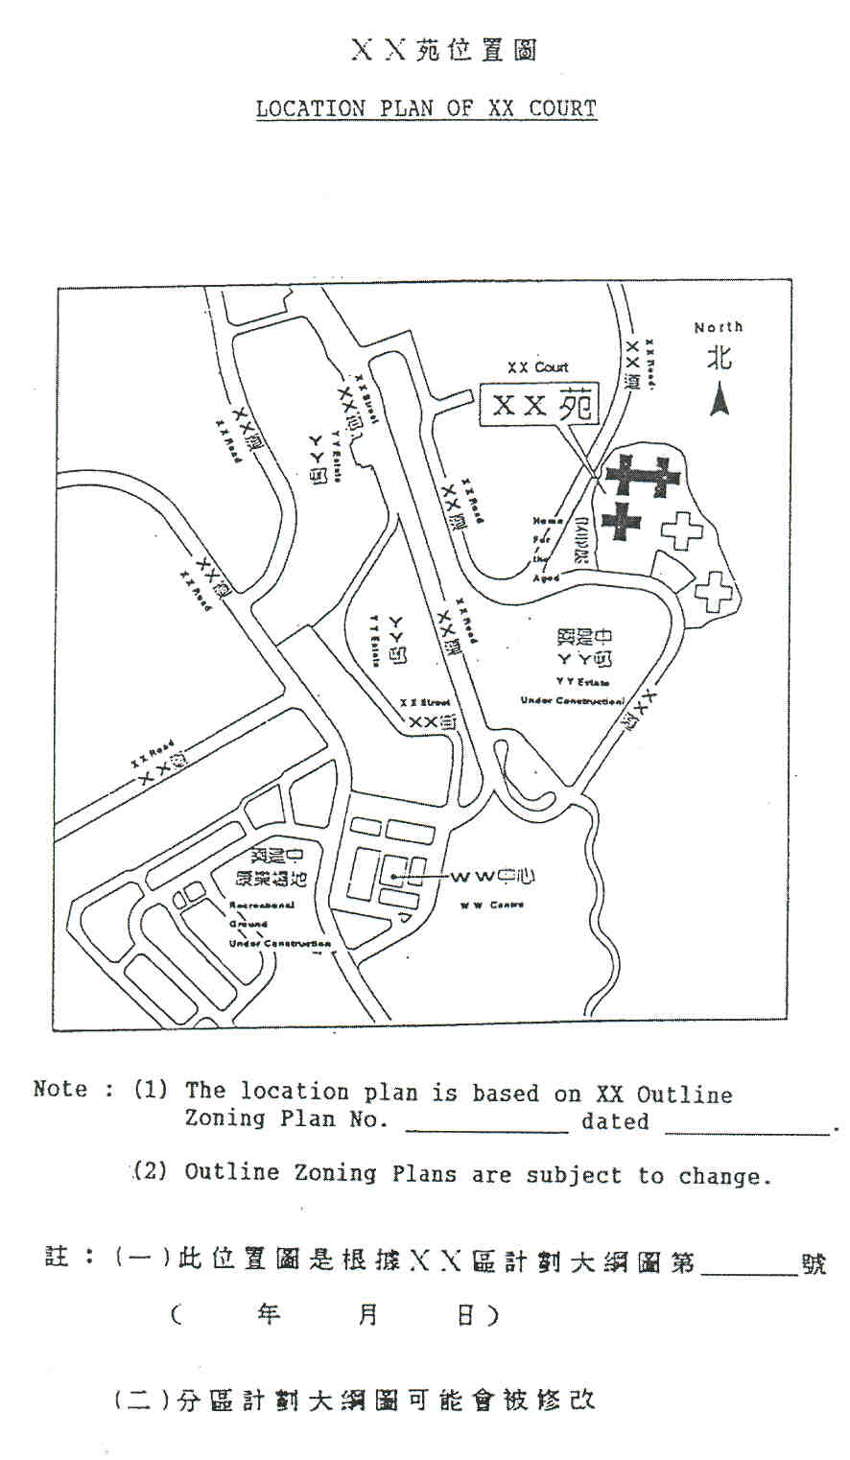
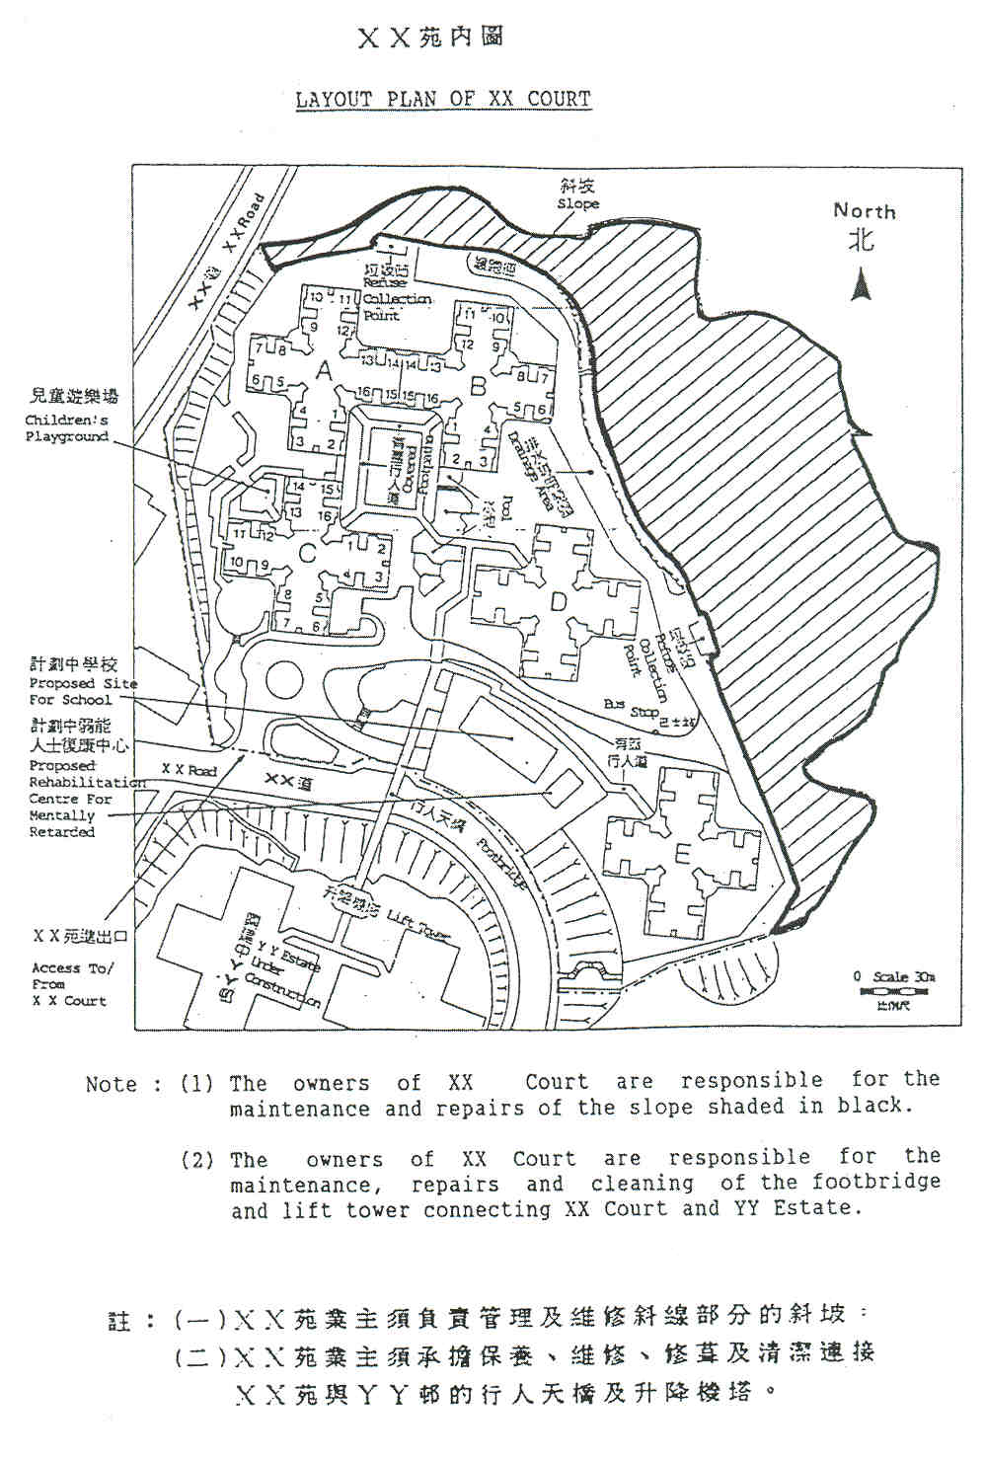

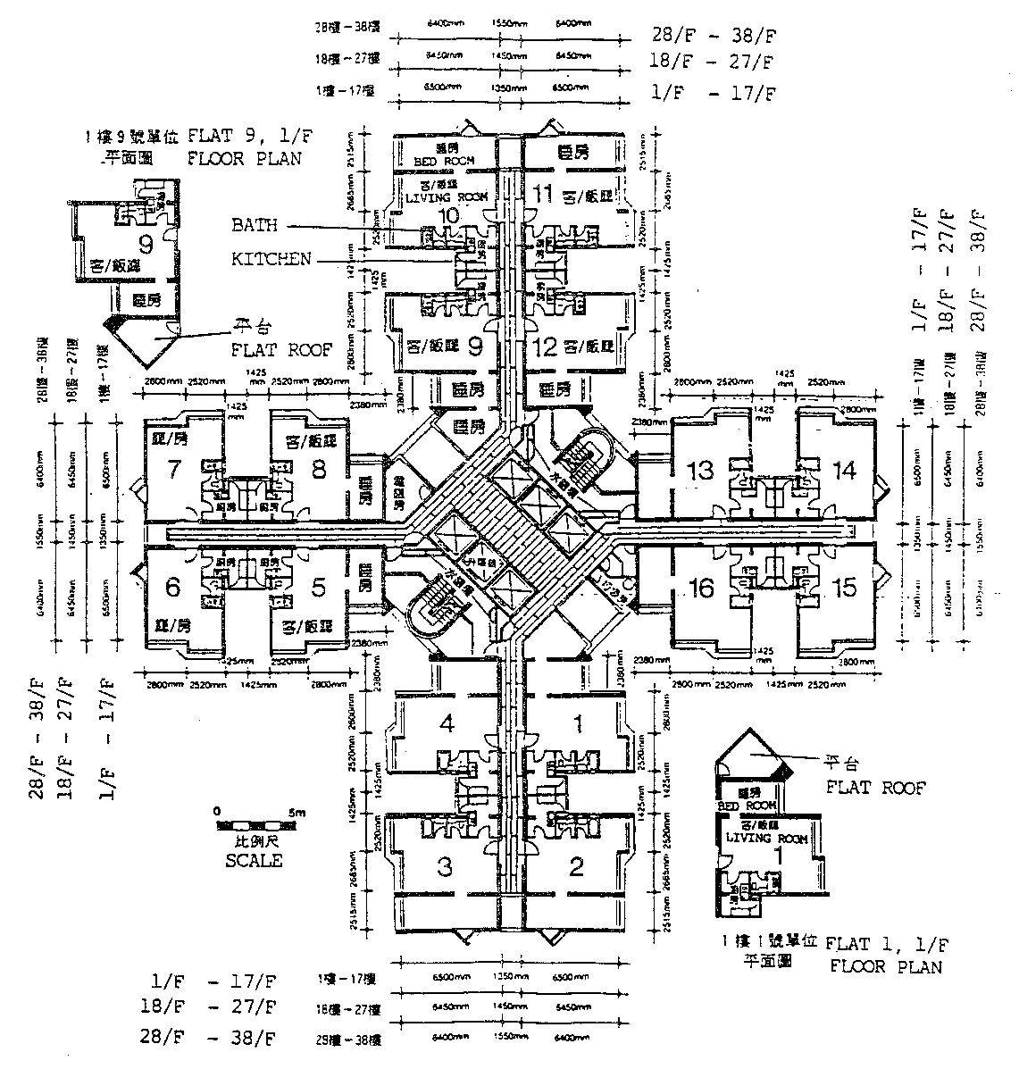

A，B，C，D，E座 1樓至38樓 樓宇樣本平面圖

FLOOR PLAN OF 1/F TO 38/F (BLOCKS A, B, C, D & E)
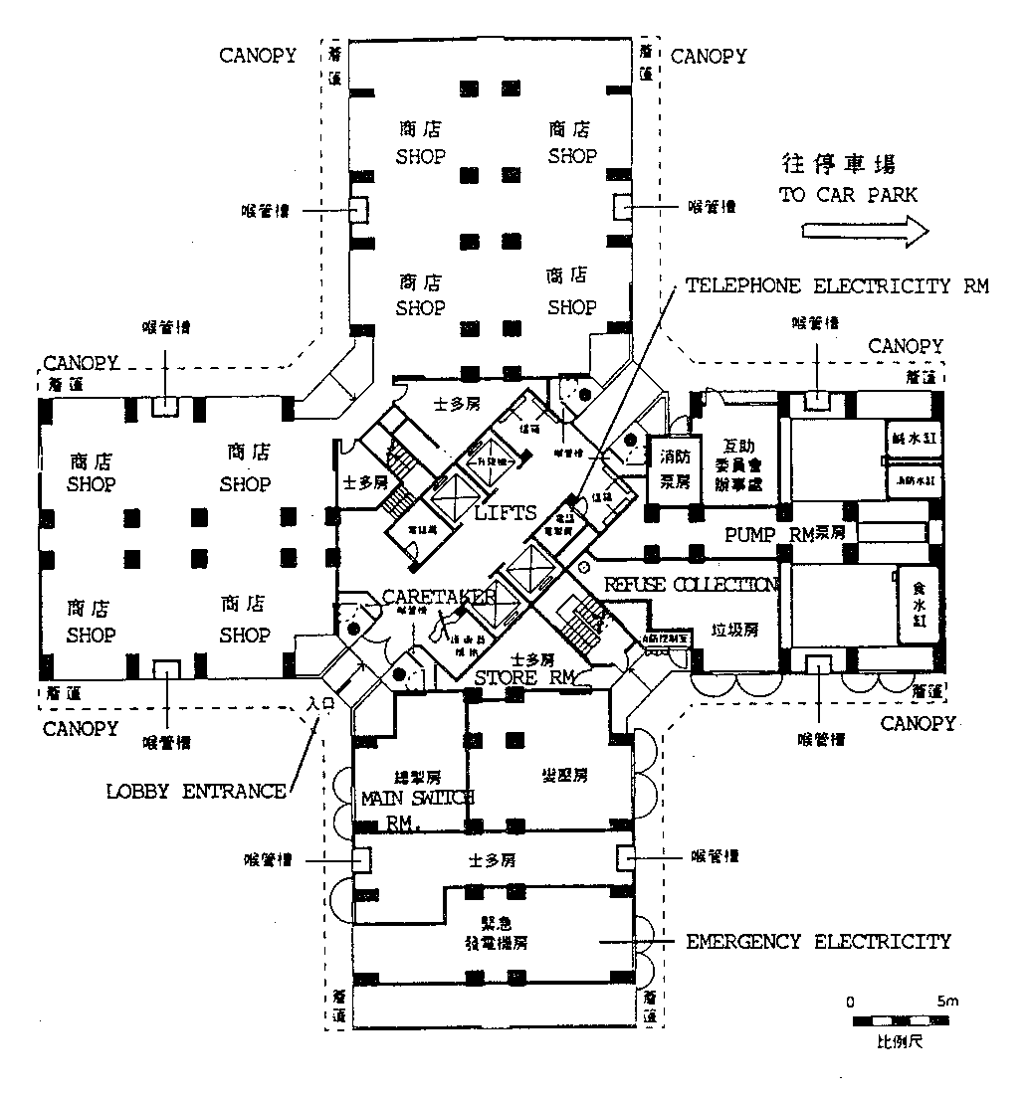

A，B，C，D，E座 地下 樓宇樣本平面圖

FLOOR PLAN OF GROUND FLOOR (BLOCKS A, B, C, D & E)

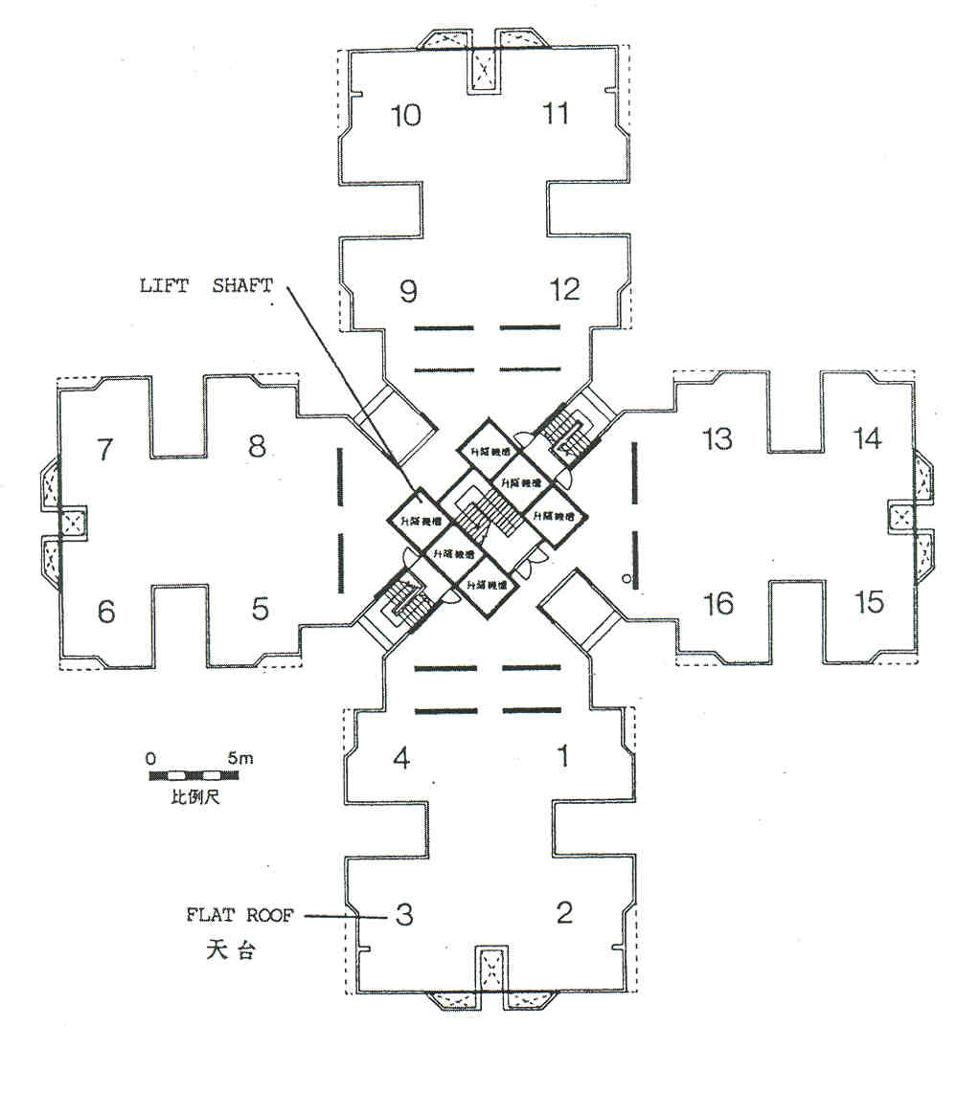
A，B，C，D，E座 天台 樓宇樣本平面圖

FLOOR PLAN OF ROOF (BLOCKS A, B, C, D & E)
(G/F) CAR PARK LAYOUT PLAN 停車場平面圖（地下）

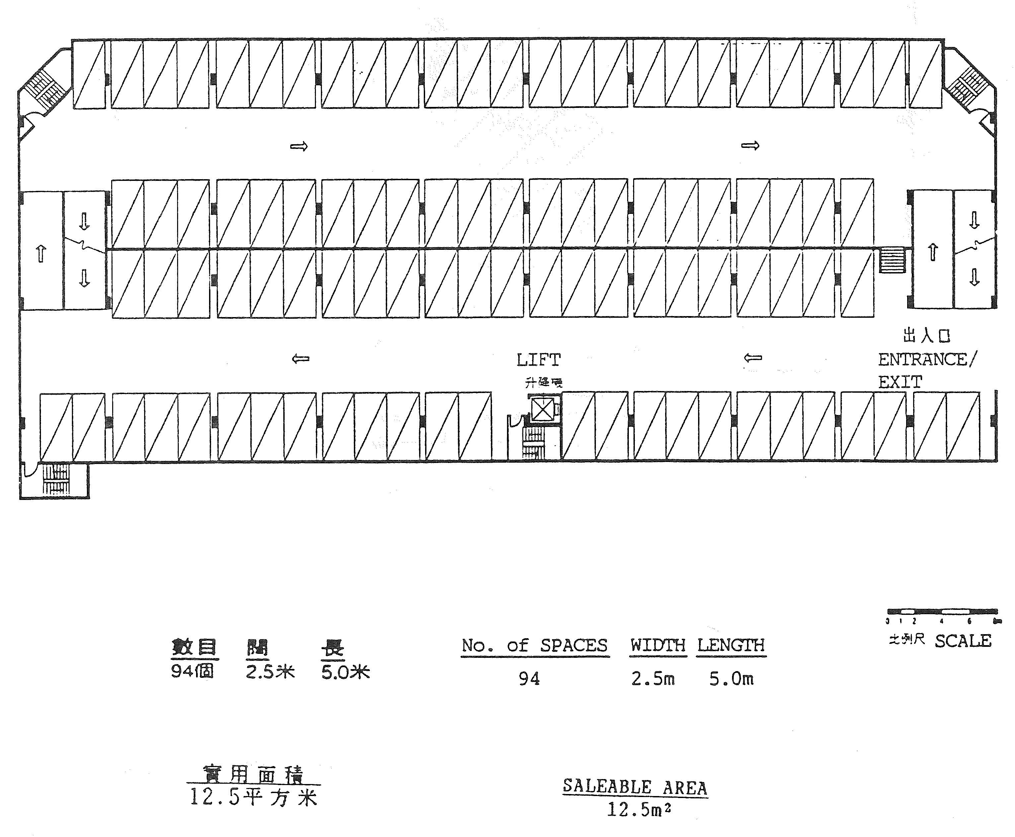

單位內外露喉管及承力牆位置圖

LOCATION OF EXPOSED PIPES AND
LOAD BEARING WALLS IN EACH UNIT

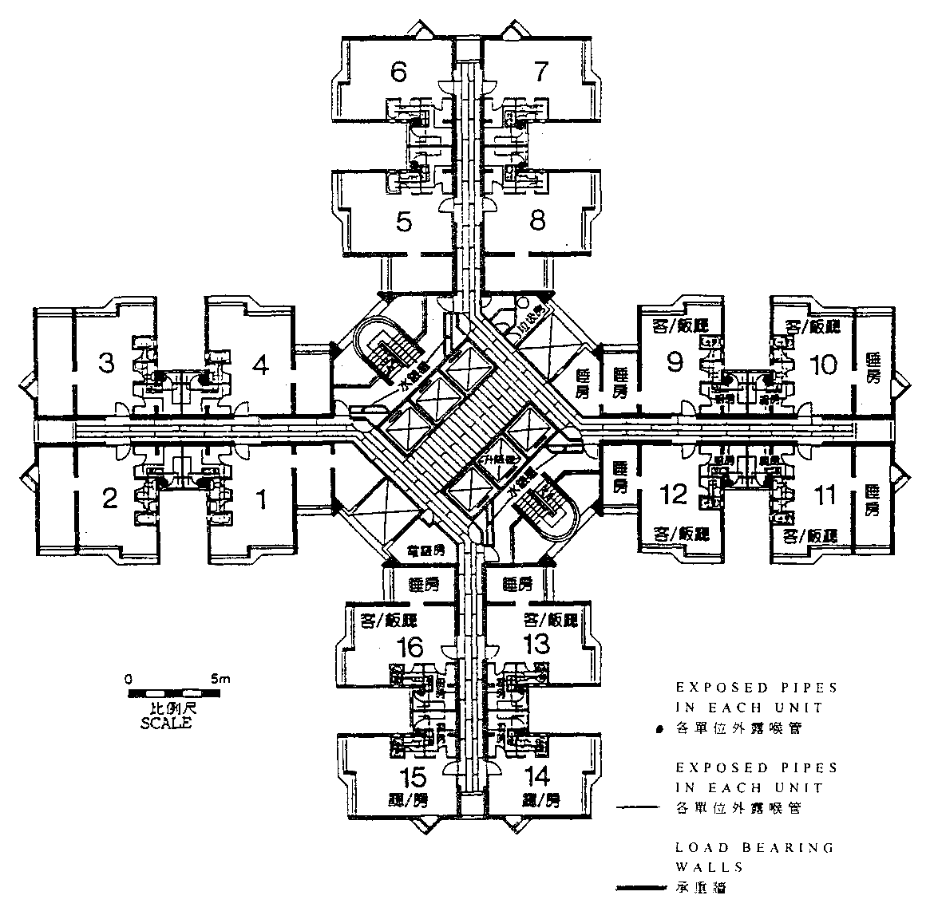

第一期A座1樓至38樓住宅面積
FLOOR AREA OF 1ST TO 38TH FLOORS
BLOCK A PHASE I

單位  FLAT | 建築面積  GROSS FLOOR AREA | 實用面積  SALEABLE AREA | （另窗台）  (AND BAY WINIDOW)
1*, 4, 5,  8, 9*, 12,  13, 16 | (m² 平方米)  34.0 | (m²平方米)  25.5 | (m²平方米)  (1.5)
2, 3, 6,  7, 10, 11,  14, 15 | 50.0 | 37.5 | (2.0)

Note: (1) 1m² = 10.764 ft²

(2) If the building plans are altered, resulting in a variation of 5% or more in the saleable area of the unit, the price will be increased or reduced accordingly and the purchaser will also be given an option to rescind the Agreement for Sale and Purchase.

(3) Certified true copies of the latest approved building plans are available for inspection at the sales office.

(4) The internal area of units on the upper floors might be slightly greater than that of the lower floors.

(5) Gross floor area of the unit means the apportioned amount of the gross floor area of the development calculated on pro-rata basis according to the saleable area of the unit.

註： （一）1平方米=10.764平方呎
（二）如大廈平面圖有所修改，而令單位之實用面積有百分之五或以上之更改，單位之售價將會適當地修改，及買家並有權取消買賣合約。
（三）最新大廈平面圖之確定副本可在售樓處查閱。
（四）較高單位之內部面積可能比低層者較大小許。
（五）單位之建築面積是指將單位所在樓宇之建築面積，按單位本身之實用面積所佔比例攤分得出之面積。
*
 | 建築面積  GROSS FLOOR AREA | 實用面積  SALEABLE AREA | （另窗台）  (AND BAY WINDOW) | （另平台）  (AND) FLAT ROOF)
 | (m²平方米) | (m²平方米) | (m²平方米) | (m²平方米)
Flat 1, 1/F  1樓1室 | 34.0 | 25.5 | (1.5) | (10.0)
Flat 9, 1/F  1樓9室 | 34.0 | 25.5 | (1.5) | (10.0)
MATTERS RELATING TO THE PRELIMINARY AGREEMENTS

- The preliminary agreement (or Memorandum for Sale) is legally a non-binding agreement.

- The preliminary agreement (or Memorandum for Sale) is non-assignable. The developer cannot sign a formal Agreement for Sale and Purchase with any person other than the purchaser who signs the preliminary agreement (or Memorandum for Sale).

- If the purchaser does not execute the Agreement for Sale and Purchase in accordance with the terms contained in the Memorandum for Sale, the developer shall be entitled to forfeit the Reservation Fee up to a sum not exceeding 3% of the Purchase Price of the flat and to cancel the Memorandum for Sale and resell the flat to others.

有關臨時合約事項

一. 臨時合約在法律上不是約束性合約。

二. 臨時合約不可轉讓他人。發展商不能與簽署臨時合約買家以外其他人士簽署正式買賣合約。

三. 若買家未能遵照樓宇訂購書內列明之條款依時簽署買賣合約，發展商有權於買方已繳付之預定費中扣除相等於總樓價百分之三，並取消樓宇訂購書及將物業轉賣他人。
公契要點

SALIENT POINTS OF DEED OF MUTUAL COVENANT (DMC)

1. The words "common parts" shall mean those parts of the Estate which are not for the use and benefit of a particular flat and for the avoidance of doubt shall exclude the school and such parts of the Estate to which equal undivided shares have been allocated and intended or designated as being for the exclusive possession or occupation of an owner or owners.

一. 「公用地方」一詞，乃指該屋苑內並非由某一單位使用及受惠之部分；為免混淆不清，該詞不包括該屋苑之學校，以及其任何平均不可分割份數已分配及擬供或指定供一名或多名業主專有或專用之部分。

- Undivided Shares and apportionment of management charges :

二. 不可分割份數及管理費用分配

1樓至38樓  單位  1/F-38/F, FLAT | 實用面積  SALEABLE AREA | 不可分割份數  NO. OF UNDIVIDED SHARE | 佔體管理費用  PORTION OF MANAGEMENT CHARGES OF WHOLE ESTATE
 | (m² 平方米)
1, 4, 5,  8, 9, 12,  13, 16 | 25.5 | 15  ――――――  12,000 | 15  ――――――  12,000
2, 3, 6,  7, 10, 11,  14, 15 | 37.5 | 22  ――――――  12,000 | 22  ――――――  12,000

3. The owners and their servants or agents and invitees of the owners have the right to use the common services and facilities and pass and repass the common areas provided that they have complied with the House Rules and other regulations for the time being in force.

三. 在不違反大廈規則及其他規例之情況下，業主及其僱員、代理人及由業主邀請或許可之人士，均可自由使用大廈之公用設施，並進出及取道大廈之公用地方。

4. Payment Upon Handover of Unit:

(1) Management Fee in Advance-Equivalent to 2 months management fee
(2) Management Fee Deposit - Equivalent to 2 months management fee
(3) Management Facility Fund - Equivalent to 1 month management fee
(4) Security Deposit for payment of Government Rates - approx. 1 month rates
(5) Deposit for Public Water & Electricity Meter
(6) Deposit for Private Water Meter.
(7) Debris removal deposit of $XX.

四. 入伙時需繳費用：

(1) 管理費上期：相等於兩個月管理費
(2) 管理費按金：相等於兩個月管理費
(3) 管理設施基金：相等於一個月管理費
(4) 政府差餉保證金：約一個月差餉金額
(5) 公眾水電錶按金
(6) 私家水錶保證金
(7) 泥頭清理按金XX元

5. No articles or obstruction may be placed in any of the common parts of the Estate or the building therein.

五. 任何物品或障礙物，均不得放置在屋苑內或其中大廈之公用地方。

6. No dog may be brought or kept upon any part of the Estate or the common parts of the building therein.

六. 在該屋苑之任何部分或屋苑大廈之公用地方，均不得攜帶或豢養犬隻。

7. Any fee payable shall be deemed to be in arrears if not paid within the specified period. Interest at 1% per month shall be charged on the amount in arrears.

七. 任何應繳費用如在到期時未繳付，則作欠款論；欠款應加繳利息為月息一厘。

8. Property Management :

- Name of manager : XYZ Property Management Limited.
- Terms of appointment of the Property Manager : The appointed Manager shall be appointed for the whole of the Lease Terms, the Manager's remuneration shall be 10% of the total management expenditure.

八. 物業管理：

(1) 物業經理人：XYZ物業管理有限公司。

(2) 經理人任期：獲任命之物業經理人任期至土地批約年期屆滿，酬金為物業管理開支百分之十。

Note: 1. A copy each of the English and the Chinese versions of the DMC are available at the sale office for inspection free of charge during normal office hours.

註： 一. 公契之中英文本可在售樓處供在正常辦公時間內免費查閱。

2. Purchasers will be notified of any subsequent changes made to the provisions in the DMC.

二. 日後公契條文若有更改，買家將被通知。

3. There are various financial liabilities which will be imposed on buyers by the DMC and buyers are advised to consult their lawyers on this.

三. 公契內有各項財政承擔加於買家，買家應與其律師查詢有關詳情。
4. The owners of XX Court are responsible for the maintenance and repairs of the adjacent slope.

四. XX苑業主須負責管理及維修苑旁斜坡。

SALIENT POINTS OF GOVERNMENT LEASE 地契要點

Lot No.: | : | NKIL NO. XXX
User Restrictions | : | Commercial/Residential
Permitted uses | : | 1st - 38th Floors : Residential  Ground Floor : Carpark , Shops
Lease Term | : | 99 years from September 1887  The term has been extended until 30 June 2047
Land Rent | : | $1 annually until 30 June 1997  After 30 June 1997, the land rent of the lot shall be a sum which is equal to 3 per cent of the annual rateable value at that time. The owners shall be liable for an apportioned amount of that sum,
Restrictions on alienation | : | Before disposing of the property or any interest in it the purchasers are required to procure from any person acquiring an interest in the property, by way of assignment, sale, mortgage, letting or otherwise, a binding undertaking to the same effect in favour of the Government.

Note : There are various financial liabilities which will be imposed on the buyers by the Government Lease and buyers are advised to consult their lawyers accordingly.

地段編號 | ： | 新九龍內地段XXX號
土地用途限制 | ： | 商業／住宅
許可用途 | ： | 1樓至38樓 ：住宅  地下 ：停車埸，商店
年期 | ： | 由1887年9月起計99年  已續期至2047年6月30日
地租 | ： | 直至1997年6月30日每年壹元  由1997年6月30日以後，整片地年租將為該地當時應課差餉估值百分之三徵收。而業主則將要分擔該年租一部分。
業主轉讓限制 | ： | 買主在轉讓業權前，必須徵得業權承讓人對政府作出地契內之承諾。

註： 地契內有各項加於買主之財政責任，買家應與其律師查詢有關詳情。

付款辦法 |  | PURCHASE PROCEDURE & TERMS OF PAYMENT
(一) 即供分期或一次過付款（特價九三折優寭） |  | (A) Immediate Mortgage Payment or Cash Payment (7% Special Discount):
1. 於簽署訂購臨時合約時，每單位先付訂金港幣十萬元。 |  | 1. A preliminary deposit of HK$100,000 for each unit to be paid upon signing of the "Memorandum for Sale".
2. 於簽署訂購臨時合約後四天內，必須到指定律師行簽署買賣合約，並付足樓價三成（包括上述訂金在內）。 |  | 2. A further deposit of 30% of the purchase price (including the aforesaid preliminary deposit) to be paid and the Sale & Purchase Agreement to be signed at the appointed Solicitor's office within 4 days after signing of the Provisional Contract.
3. 樓價七成於簽署買賣合約後十天內以現金或按揭貸款付清。 |  | 3. 70% of the purchase price to be paid within 10 days after signing of the Sale & Purchase Agreement in cash or by mortgage loan.
(二) 指定日期付款（照足訂價） |  | (B) Regular Payment (At List Price):
1. 於簽署訂購臨時合約時，每單位先付訂金港幣十萬元。 |  | 1. A preliminary deposit of HK$100,000 for each unit to be paid upon signing of the "Memorandum for Sale".
2. 於簽署訂購臨時合約後四天內，必須到指定律師行簽署買賣合約，並付足樓價10%（包括上述訂金在內）。 |  | 2. A further deposit of 10% of the purchase price (including the aforesaid preliminary deposit) to be paid and the Sale & Purchase Agreement to be signed at the appointed Solicitor's office within 4 days after signing of the Provisional Contract.
3. 於1993年5月15日前付清樓價2.5%。 |  | 3. A further deposit of 2.5% of the purchase price to be paid on or before 15th May 1993.
4. 於1993年7月31日前付清樓價2.5%。 |  | 4. A further deposit of 2.5% of the purchase price to be paid on or before 31st July 1993.
5. 樓價八成半由本公司負責安排按揭，於政府同意簽契紙(Consent to Assign)發出後，再由賣方以書面通知買方於十四天內付清及成交。 |  | 5. 85% of the purchase price through the mortgage arranged by the Developer to be paid within 14 days of the purchaser being notified in writing that the Consent to Assign has been issued.

Notes:

(1) Mortgages up to 70 per cent of the purchase price are currently provided by XXX Bank. The interest rate for mortgage granted by XXX Bank is prime rate plus 1.75% (the prime rate is currently 6.5% per annum.)

(2) The mortgage arranged by the Developer (specified in (B) 5 above) will carry an interest rate of 2.75% above the prime rate. The developer reserves the right to remortgage the property and any costs incurred in remortgaging will be borne by the developer alone.

註：

(1) XXX銀行提供最多樓價七成之按揭。按揭利率為最優惠利率加1.75厘（最優惠利率現時為6.5厘一年）。

(2) 發展商所提供之按揭（見 (二)5），利率為最優惠利率加2.75厘。發展商保留權利將物業轉按，而轉按有關費用則由發展商負擔。
TRANSFER TO SUB-PURCHASERS

- Purchasers are not permitted to transfer their rights to another person before executing the formal Agreement for Sale and Purchase.

- After execution of the formal Agreement for Sale and Purchase, any transfer subject, to the approval of the developer will be charged a handling fee of HK$10,000.

- Any application for transfer to sub-purchaser must be made in person by the purchaser and sub-purchaser jointly at the sales office.

轉名給二手買家

一. 買方在未簽署買賣合約前，不得將其訂購權益轉讓。

二. 當簽妥買賣合約後，經發展商批准轉名時，每次須繳付手續費港幣壹萬元正。

三. 任何轉名申請必須由買家及二手買家共同親身到售樓處辦理。

DEFECT LIABILITY PERIOD

The Defect Liability Period is 6 months from the completion of the sale and purchase.

保養期

樓宇內設施之保養期為由完成買賣交易起六個月內。
FITTINGS & FINISHES

1. Exterior

(a) External Walls

Finished with XX (country) XX (brand) glazed ceramic tiles and XX (country) XX (brand) paint.

(b) Windows

All units fitted with XX (country) XX (brand) aluminium frames together with glass.

(c) Bay Windows

Bay windows are of XX (country) XX (brand) granite.

(d) Planter

Made of XX (country) XX (brand) granite.

(e) Verandah/balcony

Verandah/balcony with XX (country) XX (brand) granite flooring.

(f) Drying facilities for clothing

Each unit has 3 racks for holding drying facilities for clothing. The racks are made of XX (country) XX (brand) steel.

2. Interior Finishes

(a) Lobbies

The floor and walls at the entrance of G/F lobby are finished with marble. Steel false ceilings are also installed. The marble used is of XX (country) XX (brand), whilst the steel for the false ceiling is of XX (country) XX (brand).

The walls and ceilings of the lobbies of 1/F to 38/F are finished with XX (country) XX (brand) emulsion paint.

(b) Internal walls and ceilings
The internal walls and ceilings are finished with XX (country) XX (brand) emulsion paint.

(c) Floors

Living/dining room and bedroom floors are finished with XX (country) XX (brand) teak parquet and XX (country) XX (brand) teak skirting.

(d) Bathroom

Walls finished with ceramic tiles running up to the ceiling. The floor and ceiling are plastered and painted with emulsion paint. The ceramic tiles are of XX (country) XX (brand). The emulsion paint is of XX (country) XX (brand).

(e) Kitchen

Walls finished with ceramic tiles running up to the ceiling. The floor and ceiling are plastered and painted with emulsion paint. The ceramic tiles are of XX (country) XX (brand). The emulsion paint is of XX (country) XX (brand).

3. Interior Fittings

(a) Doors

The doors of the entrance and kitchen of each unit are of solid-core teak veneered plywood. The entrance door is fitted with door lock and viewer. Other doors are made of veneered plywood.

The teak veneered plywood is of XX (country) XX (brand). The door lock is of XX (country) XX (brand). The viewer is of XX (country) XX (brand). The veneered plywood is of XX (country) XX (brand).

(b) Bathroom

XX (country) XX (brand) washbasin;
XX (country) XX (brand) toilet;
XX (country) XX (brand) bath tub (1000mm x 700mm);
XX (country) XX (brand) shower;
XX (country) XX (brand) hot and cold water taps;
XX (country) XX (brand) towel rail;
XX (country) XX (brand) shower curtain rail;
XX (country) XX (brand) soap holder;
XX (country) XX (brand) toilet-paper holder.

(c) Kitchen

XX (country) XX (brand) stainless steel sink;
XX (country) XX (brand) gas supply hose;
XX (country) XX (brand) kitchen cabinets with plastic laminate finish;
XX (country) XX (brand) water taps.

(d) Bedroom

One XX, (country) XX (brand) built-in wardrobe in the master bedroom.

(e) Telephone and Aerials

A telephone outlet and a TV socket in the living room.

The telephone outlet is of XX (country) XX (brand). The TV connection is of XX (country) XX (brand).

(f) Electricity

XX (country) XX (brand) concealed conduit wiring;
XX (country) XX (brand) power points (2 for living room, 1 for each bedroom);
XX (country) XX (brand) air-conditioner points (1 for living room, 1 for each bedroom);
all power points with safety devices against electricity leakage.

(g) Gas/Electricity Supply

Gas and electricity supply mains at kitchen.

(h) Washing Machine Connection Point

Water supply point and drainage point for washing machine in the Kitchen.

(i) Water Supply & Pipes

Exposed copper cold water pipes of XX (country) XX (brand).
Concealed copper hot water pipes of XX (country) XX (brand).

(j) Air-conditioners

Every unit is fitted with 3 XX (country) XX (brand) air-conditioners, located respectively in the master bedroom, bedroom and living room.

4 Security Facilities

- Security point at entrance lobby : Security point at the entrance lobby of each block.

- Entrance lobby access door at G/F is operated by XX (country) XX (brand) door-phone system and secret code entry panel..

- XX (country) XX (brand) closed circuit TV cameras inside all lifts.

5. Miscellaneous

(a) Lifts

6 XX (country) XX (brand) lifts for each block. The lifts serve all floors.

(b) Letter Box

XX (country) XX (brand) stainless steel letter boxes at G/F entrance lobby.

(c) Refuse Collection

Refuse collection room and refuse chute on each floor. Central refuse collection room on G/F.

(d) Water/Electricity/Gas Meters

The gas meter is at the balcony of each unit. The water meter is inside the meter cabinet on each floor. The electricity meter is installed at the meter room on each floor.

(e) Air-conditioning Plant

The building is not serviced by central air-conditioning system. No air-conditioning plants are installed in the building.

Note: If the intended materials become unavailable, the developers can use substitute materials provided that the authorized person of the development project certifies that in his professional opinion the substitute materials are of comparable quality and standard as the intended materials.

樓宇的裝置及裝飾

1. 大廈外型

(a) 外牆：鋪砌XX國XX牌磁面石XX國XX牌噴漆。

(b) 窗戶：各單位全部XX國XX牌鋁窗，配備玻璃。

(c) 窗台：窗台面鋪XX國XX牌麻石。

(d) 花槽：用XX國XX牌麻石。

(e) 平台：平台地面用XX國XX牌麻石。

(f) 曬衣裝置：每戶均裝有三個曬衣插放位。放位用XX國XX牌鋼製造。

2. 室內裝飾

(a) 大堂： 地下大堂入口地台及牆身均鋪雲石，並裝設鋁質假天花。雲石是XX國XX牌，而假天花之鋁是XX國XX牌。
1樓至38樓大堂牆及天花均髹上XX國XX牌乳膠漆。

(b) 牆壁及天花：單位內牆及天花髹上XX國XX牌乳膠漆。

(c) 地板：客飯廳及睡房鋪XX國XX牌柚木地板，配XX國XX牌木牆腳線。

(d) 浴室： 牆身鋪瓷磚至天花底，地台及天花均經批盪及髹上乳膠漆。
瓷磚是XX國XX牌，乳膠漆是XX國XX牌。

(e) 廚房： 牆身鋪瓷磚至天花底，地台及天花均經批盪及髹上乳膠漆。
瓷磚是XX國XX牌，乳膠漆是XX國XX牌。

3. 室內設備

(a) 門： 每單位大門及廚房採用柚木夾板實心木門。大門配上門鎖及防盜眼。其他房門均用夾板木門。
柚木夾板是XX國XX牌。夾板是用XX國XX牌。大門鎖是XX國XX牌。防盜眼是XX國XX牌。

(b) 浴室設備： 裝置洗面盆、坐廁、浴缸（1000毫米ｘ700毫米）、電話式花灑、冷熱水喉、毛巾架、浴簾通、梘盅及廁紙斗。
洗面盆是XX國XX牌，坐廁是XX國XX牌，浴缸是XX國XX牌，花灑是XX國XX牌，冷熱水喉是XX國XX牌，毛巾架是XX國XX牌，浴簾通是XX國XX牌，梘盅是XX國XX牌，廁紙斗是XX國XX牌。

(c) 廚房： 裝設XX國XX牌不銹鋼洗滌盆及XX國XX牌煤氣喉管，XX國XX牌防火膠板面廚櫃，XX國XX牌水龍頭。

(d) 睡房：主人睡房有XX國XX牌入牆衣櫃一個。

(e) 電話及天線： 客廳預留電話插座，此外，客廳設有一個公共天線插座。
電話插座是XX國XX牌，公共天線插座是XX國XX牌。

(f) 電力裝置： 單位裝置XX國XX牌入牆暗線，XX國XX牌插座（客廳兩個，每個睡房一個）；XX國XX牌冷氣機電位（客廳一個，每個睡房一個）。全部電力插座由漏電斷路保護。

(g) 煤氣：廚房均預留煤氣喉位。
電力：預留電力供應總掣於廚房。

(h) 洗衣機去水位：廚房內設洗衣機入水及去水位。

(i) 來水喉： 外露XX國XX牌銅質泠水鐵喉。
入牆XX國XX牌銅質熱水鐡喉。

(j) 冷氣機：每單位有三部XX國XX牌窗口式冷氣機，分別在主人房，睡房及客廳。

4. 保安設施

(a) 大堂保安處：每座大廈大堂入口設有保安處。

(b) 地下大堂入口大門裝有XX國XX牌對講機系統及密碼門鎖。

(c) 電梯內設有XX國XX牌閉路電視。

5. 其他
(a) 升降機： 每座裝設六部XX國XX牌升降機。每層均有升降機直達。

(b) 信箱: 地下大堂入口設有XX國XX牌不銹鋼信箱。

(c) 垃圾收集: 每層均設有垃圾房及垃圾槽，地下則設有主垃圾房。

(d) 測錶: 煤氣錶裝於每戶露台，水錶裝於每層的水錶櫃，電錶則裝於每層的獨立錶房內。

(e) 冷氣機房: 本大廈並沒有中央冷氣系統，並沒有冷氣機房設施。

附註： 如所述設備用料日後缺貨，發展商有權採用其他代用材料，但發展商所委任之建築師必須證實在其專業眼光中，代用材料跟原述材料是屬於同等品質水平。

Expected Occupation Permit Date : August 1993.
估計入伙紙日期：1993年8月

The Construction Completion Date stated
in the Sale & Purchase Agreement : On or before 30 November 1993
買賣合約訂定的建築完成日期：1993年11月30日前

Note : This development does not require a Certificate of Compliance.
註：本屋苑不需满意紙。

LATE COMPLETION INTERESTS 過期完成交易利息

(1) If the purchaser fails to complete the sale and purchase on or before the date as stipulated in the Agreement for Sale and Purchase, the developer shall be entitled to, without prejudice to any other remedies, demand from the purchaser interests on the unpaid part of the purchase price at the rate of 2% per annum above the prime rate.

一. 如買家未能照買賣合約所指定日期或之前完成交易，發展商有權除採取其他行動外，向買家收取未付樓價利息，而利率為最優惠利率加年息2厘。

(2) If the developer fails to complete the construction of the units on or before the date as stipulated in the Agreement for Sale and Purchase, purchasers shall be entitled to, without prejudice to any other remedies, receive from the developer interests on the part of the purchase price already paid at the rate of 2% per annum above the prime rate.

However, purchasers shall not be entitled to any such interests if the authorized person grants extension for the completion of the construction of the units. Such extension will be granted if the delay is caused exclusively by any one or more of the following reasons: strike or lock-out of workmen; riots or civil commotion; force majeure or Act of God; fire or other accident beyond the developer's control; war; or inclement weather.

二. 如發展商未能按買賣合約所指定日期或之前完成單位之建築，買家有權除採取其他行動外，向發展商收取已付樓價之利息，利率為最優惠利率加年息2厘。

但如建築師允許延長單位之建築期，買家將不可有權收取上述利息。而建築師會允許延長建築期，只要建築是因為下列一項或多項理由而延誤：工人罷工、暴動、天災、火警或其他不在發展商控制之意外、戰爭或壞天氣。

APPENDIX III

Mock-Up Price List
PRICE LIST OF BLOCK A
A座價目表

Flat No  單位 |  | 1 | 2 | 3 | 4 | 5 | 6 | 7 | 8 | 9 | 10 | 11 | 12 | 13 | 14 | 15 | 16
Gross Floor Area (m²)  建築面積 （平方米） |  | 34.0 | 50.0 | 50.0 | 34.0 | 34.0 | 50.0 | 50.0 | 34.0 | 34.0 | 50.0 | 50.0 | 34.0 | 34.0 | 50.0 | 50.0 | 34.0
Saleable Area (m²)  實用面積 （平方米） |  | 25.5 | 37.5 | 37.5 | 25.5 | 25.5 | 37.5 | 37.5 | 25.5 | 25.5 | 37.5 | 37.5 | 25.5 | 25.5 | 37.5 | 37.5 | 25.5
and bay window (m²)  另窗台（平方米） |  | 1.5 | 2.0 | 2.0 | 1.5 | 1.5 | 2.0 | 2.0 | 1.5 | 1.5 | 2.0 | 2.0 | 1.5 | 1.5 | 2.0 | 2.0 | 1.5
38th Floor | 三十八樓 | $  980000 | $  933100 | $  898500 | $  794900 | $  819100 | $  663800 | $  683300 | $  843600 | $  941400 | $  902400 | $  943500 | $  842700 | $  843300 | $  683200 | $  661000 | $  815700
37th Floor | 三十七樓 | 996500 | 948500 | 913900 | 808700 | 832900 | 674900 | 694400 | 857400 | 957900 | 917800 | 958900 | 856500 | 857100 | 694300 | 672100 | 829500
36th Floor | 三十六樓 | 995700 | 947700 | 913100 | 808000 | 832200 | 674300 | 693800 | 856700 | 957100 | 917000 | 958100 | 855800 | 856400 | 693700 | 671500 | 828800
35th Floor | 三十五樓 | 994900 | 946900 | 912300 | 807300 | 831500 | 673700 | 693200 | 856000 | 956300 | 916200 | 957300 | 855100 | 855700 | 693100 | 670900 | 828100
34th Floor | 三十四樓 | 994100 | 946100 | 911500 | 806600 | 830800 | 673100 | 692600 | 855300 | 955500 | 915400 | 956500 | 854400 | 855000 | 692500 | 670300 | 827400
33rd Floor | 三十三樓 | 993300 | 945300 | 910700 | 805900 | 830100 | 672500 | 692000 | 854600 | 954700 | 914601 | 955700 | 853700 | 854300 | 691900 | 669700 | 826700
32nd Floor | 三十二樓 | 992500 | 944500 | 909900 | 805200 | 829400 | 671900 | 691400 | 853900 | 953900 | 913800 | 954900 | 853000 | 853600 | 691300 | 669100 | 826000
31st Floor | 三十一樓 | 991700 | 943700 | 909100 | 804500 | 828700 | 671300 | 690800 | 853200 | 953100 | 913000 | 954100 | 852300 | 852900 | 690700 | 668500 | 825300
30th Floor | 三 十 樓 | 990900 | 942900 | 908300 | 803800 | 828000 | 670700 | 690200 | 852500 | 952300 | 912200 | 953300 | 851600 | 852200 | 690100 | 667900 | 824600
29th Floor | 二十九樓 | 990100 | 942100 | 907500 | 803100 | 827300 | 670100 | 689600 | 851800 | 951500 | 911400 | 952500 | 950900 | 851500 | 689500 | 667300 | 823900
28th Floor | 二十八樓 | 989300 | 941300 | 906700 | 802400 | 826600 | 669500 | 689000 | 851100 | 950700 | 910600 | 951700 | 850200 | 850800 | 688900 | 666700 | 823200
27th Floor | 二十七樓 | 988500 | 940500 | 905900 | 801700 | 825900 | 668900 | 688400 | 850400 | 949900 | 909800 | 950900 | 849500 | 850100 | 688300 | 666100 | 822500
26th Floor | 二十六樓 | 987700 | 939700 | 905100 | 801000 | 825200 | 668300 | 687800 | 849700 | 949100 | 909000 | 950100 | 848800 | 849400 | 687700 | 665500 | 821800
25th Floor | 二十五樓 | 986900 | 938900 | 904300 | 800300 | 824500 | 667700 | 687200 | 849008 | 948300 | 908200 | 949300 | 848100 | 848700 | 687100 | 664 900 | 821100
24th Floor | 二十四樓 | 985300 | 937400 | 902800 | 798900 | 823100 | 666600 | 686100 | 847600 | 946700 | 906700 | 947800 | 846700 | 847300 | 686000 | 663800 | 819700
23rd Floor | 二十三樓 | 983700 | 935900 | 901300 | 797500 | 821700 | 665500 | 685000 | 846200 | 945100 | 905200 | 946300 | 845300 | 845900 | 684906 | 662700 | 818300
22nd Floor | 二十二樓 | 982100 | 934400 | 899800 | 796100 | 820300 | 664400 | 683900 | 844800 | 943500 | 901700 | 944800 | 843900 | 844500 | 683800 | 661600 | 816900
21st Floor | 二十一樓 | 980500 | 932900 | 898300 | 794700 | 818900 | 663300 | 682800 | 843400 | 941900 | 902200 | 943300 | 842500 | 843100 | 682700 | 660500 | 815500
20th Floor | 二 十 樓 | 978900 | 931400 | 896800 | 793300 | 817500 | 662200 | 681700 | 842000 | 940300 | 900700 | 941800 | 841100 | 841700 | 681600 | 659400 | 814100
19th Floor | 十 九 樓 | 667500 | 928300 | 893700 | 790500 | 814700 | 660000 | 679500 | 839200 | 937000 | 897600 | 938700 | 838300 | 838900 | 679400 | 657200 | 811300
18th Floor | 十 八 樓 | 968900 | 925200 | 890600 | 787700 | 811900 | 657800 | 677300 | 836400 | 933700 | 894500 | 935600 | 835500 | 836100 | 677200 | 655000 | 808500
17th Floor | 十 七 樓 | 965600 | 922100 | 887500 | 784900 | 809100 | 655600 | 675100 | 833600 | 930400 | 891400 | 932500 | 832700 | 833300 | 675000 | 652800 | 805700
16th Floor | 十 六 樓 | 962300 | 919000 | 884400 | 782100 | 806300 | 653400 | 672900 | 830800 | 927100 | 888300 | 929400 | 829900 | 830500 | 672800 | 650600 | 802900
15th Floor | 十 五 樓 | 959000 | 915900 | 881300 | 779300 | 803500 | 651200 | 670700 | 828000 | 923800 | 885200 | 926300 | 827100 | 827700 | 670600 | 648400 | 800100
14th Floor | 十 四 樓 | 955700 | 912800 | 878200 | 776500 | 800700 | 649000 | 668500 | 825200 | 920500 | 882100 | 923200 | 824300 | 824900 | 668400 | 646200 | 797303
13th Floor | 十 三 樓 | 952400 | 909700 | 875100 | 773700 | 797900 | 646800 | 666300 | 822400 | 917200 | 879000 | 920100 | 821500 | 822100 | 666200 | 644000 | 794500
12th Floor | 十 二 樓 | 949100 | 906600 | 872000 | 770900 | 795100 | 644600 | 664100 | 819600 | 913900 | 875900 | 917000 | 818700 | 819300 | 664000 | 641800 | 791700
11th Floor | 十 一 樓 | 945800 | 903500 | 868900 | 768100 | 792300 | 642400 | 661900 | 816800 | 910600 | 872800 | 913900 | 815900 | 816500 | 661800 | 639600 | 788900
10th Floor | 十 樓 | 940900 | 898900 | 865800 | 765300 | 789500 | 640200 | 659700 | 814000 | 907300 | 869700 | 910800 | 811800 | 813700 | 659600 | 637400 | 786100
9th Floor | 九 樓 | 936000 | 894300 | 862700 | 762500 | 786700 | 638000 | 657500 | 811200 | 904000 | 866600 | 907700 | 807700 | 810900 | 657400 | 635200 | 783300
8th Floor | 八 樓 | 931100 | 889700 | 859600 | 759700 | 783900 | 635800 | 655300 | 808400 | 900700 | 863500 | 904600 | 803600 | 808100 | 655200 | 633000 | 780500
7th Floor | 七 樓 | 926200 | 885100 | 856500 | 756900 | 781100 | 633600 | 653100 | 805600 | 897400 | 860400 | 900000 | 799500 | 805300 | 653000 | 630800 | 777700
6th Floor | 六 樓 | 921300 | 880500 | 853400 | 754100 | 778300 | 631400 | 650900 | 802800 | 894100 | 857300 | 895400 | 795400 | 802500 | 650800 | 628600 | 774900
5th Floor | 五 樓 | 916400 | 875900 | 850300 | 751300 | 775500 | 629200 | 648700 | 800000 | 890800 | 854200 | 890800 | 791300 | 799700 | 648600 | 626400 | 772100
4th Floor | 四 樓 | 911500 | 871300 | 847200 | 748500 | 772700 | 627000 | 646500 | 797200 | 887500 | 851100 | 886200 | 787200 | 796900 | 646400 | 624200 | 769300
3rd Floor | 三 樓 | 903300 | 863600 | 841700 | 743000 | 767200 | 622600 | 640900 | 791700 | 879300 | 843400 | 879500 | 780300 | 791400 | 642000 | 619800 | 763800
2nd Floor | 二 樓 | 889300 | 850500 | 829600 | 732600 | 756800 | 614300 | 630900 | 771000 | 864500 | 829600 | 865400 | 768500 | 781000 | 633700 | 611500 | 753400
1st Floor | 一 樓 | @890100 | 787500 | 791200 | 698000 | 715300 | 581000 | 611500 | 729500 | 808900 | 795000 | 833100 | 746400 | 760300 | 617000 | 578200 | 698100

Note: The above prices are list prices 註：上述樓價均為原來定價

@, - This unit has flat roof of 10m² @, - 此單位有平台10平方米

All flats nos. 2, 3 and 4 are reserved for future internal sale. All flats nos 10, 11 and 12 have been sold through internal sale subject to a "buy-back arrangement".

所有2、3及4號單位只供未來內部認購。所有10、11及12 號單位已經有回購協議之內部認購出售。
付款辦法 |  | PURCHASE PROCEDURE & TERMS OF PAYMENT
(一) 即供分期或一次過付款（特價九三折優惠） |  | (A) Immediate Mortgage Payment or Cash Payment (7% Special Discount):
1. 於簽署訂購臨時合約時，每單位先付訂金港幣十萬元。 |  | (1) A preliminary deposit of HK$100,000 for each unit to be paid upon signing of the "Memorandum for Sale".
2. 於簽署訂購臨時合約後四天內，必須到指定律師行簽署買賣合約，並付足樓價三成（包括上述訂金在內）。 |  | (2) A further deposit of 30% of the purchase price (including the aforesaid preliminary deposit) to be paid and the Sale & Purchase Agreement to be signed at the appointed Solicitor's office within 4 days after signing of the Provisional Contract.
3. 樓價七成於簽署買賣合約後十天內以現金或按揭貸款付水清。 |  | (3) 70% of the purchase price to be paid within 10 days after signing of the Sale & Purchase Agreement in cash or by mortgage loan.
(二) 指定日期付款（照足訂價） |  | (B) Regular Payment (At List Price):
1. 於簽署訂購臨時合約時，每單位先付訂金港幣十萬元。 |  | (1) A preliminary deposit of HK$100,000 for each unit to be paid upon signing of the "Memorandum for Sale".
2. 於簽署訂購臨時合約後四天內，到指定律師行簽署買賣合約，並付足樓價10%（包括上述訂金在內）。 |  | (2) A further deposit of 10% of the purchase price (including the aforesaid preliminary deposit) to be paid and the Sale & Purchase Agreement to be signed at the appointed Solicitor's office within 4 days after signing of the Provisional Contract.
3. 於1993年5月15日前付樓價2.5%。 |  | (3) A further deposit of 2.5% of the purchase price to be paid on or before 15th May 1993.
4. 於1993年7月31日日前付樓價2.5%。 |  | (4) A further deposit of 2.5% of the purchase price to be paid on or before 31st July 1993.
5. 樓價八成半由本公司負責安排按揭，於政府同意簽契紙(Consent to Assign)發出後，再由賣方以書面通知買方於十四天內付清及成交。 |  | (5) 85% of the purchase price through the mortgage arranged by the Developer to be paid within 14 days of the purchaser being notified in writing that the Consent to Assign has been issued.

Notes: |  | 附註：
(1) Mortgages up to 70 per cent of the purchase price are currently provided by XXX Bank. The interest rate for mortgage granted by XXX Bank is prime rate plus 1.75% (the prime rate is currently 6.5% per annum.) |  | 一. XXX銀行提供最多樓價七成之按揭。按揭利率為最優惠利率加1.75厘（最優惠利率現時為6.5厘一年）。
(2) The mortgage arranged by the Developer (specified in (B) 5 above) will carry an interest rate of 2.75% above the prime rate. The developer reserves the right to remortgage the property and any costs incurred in remortgaging will be borne by the developer alone. |  | 二. 發展商所提供之按揭（見(二)5），利率為最優惠利率加2.75厘。發展商保留權利將物業轉按，而轉按有關費用則由發展商負擔。
(3) All legal costs, stamp duty, plan fees and all other incidental expenses related to the purchase shall be borne by the purchaser. |  | 三. 所有律師費、厘印費、圖則費及其他一切購買樓宇所需的費用，需由買家繳付。
(4) If any purchaser instructs his own solicitor to act for him in the purchase, the purchaser shall be responsible for the payment of the charges of the developer's solicitors. |  | 四. 若任何買家自行選用律師代表購入樓宇，買家必須負責支付發展商之律師費用。
(5) General scales of legal costs and stamp duties will be provided for inspection at the sales office upon request. |  | 五. 一般律費用及厘印費收費表可在售樓處索閱。
(6) A total of 380 flats will be put up for public sale. Another 114 flats are reserved for future internal sale. A further 114 flats have been sold through internal sale subject to a "buy-back arrangement". |  | 六. 總數380個單位供公眾認購，另114個單位供未來內部認購。再另外114個單位已經有回購協議之內部認購出售。
(7) If the purchaser does not execute the Agreement for Sale and Purchase in accordance with the terms contained in the Memorandum for Sale, the developer shall be entitled to forfeit the Reservation Fee up to a sum not exceeding 3% of the Purchase Price of the flats. |  | 七. 若買家未能遵照樓宇訂購書內列明之條款依時簽署買賣合約，發展商有權於買方已繳付之預定費中扣除相等於總樓價百分之三。
(8) Purchasers are not permitted to transfer their rights to another person before executing the formal Agreement for Sale and Purchase. |  | 八. 買家在未簽署買賣合約前，不得將其訂購權益轉讓。
(9) After execution of the formal Agreement for Sale and Purchase, any transfer subject to the approval of the developer will be charged a handling fee of HK$10,000. |  | 九. 當簽妥買賣合約後，經發展商批准轉名時，每次須繳付手續費港幣壹萬元正。

APPENDIX IV

Land Office Circular Memorandum No. 101
Ref : LO 13/953/56 Registrar General's Department
(Land Office)
Queensway Government Offices
19th Floor, 66 Queensway
Hong Kong

21 February 1991

LAND OFFICE CIRCULAR MEMORANDUM NO. 101

- Mandatory disclosure of information in the Sale
of Units in uncompleted developments
- Consent Scheme
___________________________________________

After a study of the subject, and after consultation with the Real Estate Developers Association, the Institutes of Chartered Surveyors, the Law Society and relevant Government Departments, the Consumer Council has recommended that more information than is disclosed at present should be made available regarding uncompleted property developments, particularly residential, in which units are to be offered for sale to the public. This will enable prospective purchasers to make better informed decisions in the purchase of their units.

This recommendation has been accepted by the Government and will be implemented by way of the Consent Scheme which is administered by my Department.

Where consent to forward sales is necessary, developers will be required to make available to the public, at least one week prior to the commencement of the sale of the units, a sales brochure which will contain a list of all the fittings and finishes and other relevant information relating to the units being offered for sale, including the information set out in the Appendices hereto. Any disclaimer of the accuracy of any such information, whether made before or after consent has been given, will be considered to be a breach of the terms of the consent.

A statement that a sales brochure complying with this Circular Memorandum has been produced and made available to prospective purchasers, and that copies have been sent to the Land Office of my Department and the Consumer Council, must henceforth be included in the Statutory Declaration to be made by a partner of the solicitor's firm lodging the consent application.

The new disclosure requirements are designed basically for the sale of units in residential developments but will be applied also, with appropriate adaptation if necessary, to commercial and industrial developments.

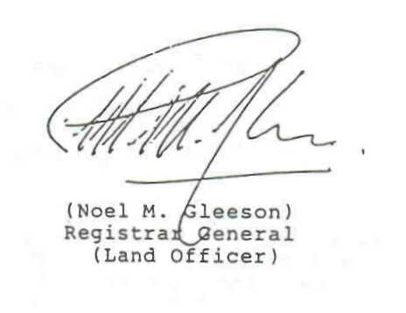

To: All Solicitors
Appendix 1

MINIMUN INFORMATION TO BE PROVIDED TO
PROSPECTIVE PURCHASERS OF UNCOMPLETED UNITS

A. Information to be Incorporated In a Sales Brochure

1. Introduction

General description of development; the identity of the intended manager, it known

2. Location Plan

Including up-dated Information on prominent environmental features in the vicinity e.g. public park, swimming pool, refuse collection point etc., intended user of surrounding areas, if known

3. Layout Plan Drawn to Scale

Including communal facilities (and their completion dates if possible); undeveloped land and its intended use within the boundary or the development; the scale used

4. Salient Points or Government Lease

Including lot number; lease term; user restrictions on the lot; onerous lease conditions (if any) which would restrict purchasers' usual legal rights.

5. Detailed Plan or a Typical Floor

Showing all principal external dimensions of the unit; external dimensions or individual compartments in each unit; the scale used, a note informing prospective purchasers (i) that the internal areas or units on upper floors will generally be slightly larger than lower floors due to the reducing thickness of' structural walls on upper levels (ii) if there are special fittings/features affecting the enjoyment of the owner or a unit (e.g. exposed pipes) (the location of such special fittings/features should be specified).

In case there is any non-typical floor, a separate floor plan should be shown.

6. Schedule of Flat Size

Indicating size of each unit in standard saleable area (as defined in Land Office Circular Memorandum No. 84), areas of bay windows, roofs, flat roofs and open yards (if any) should be specified separately

7. Fittings and Finishes

Refer to Appendix 2

8. Anticipated Completion Date of the Building

9. Salient Points of DMC

Including definition of common areas; terms or appointment of Manager; principle/basis of fixing management fee; management fee deposit; a note informing prospective purchasers that a full script of the DMC is available upon request

10. Carpark

Specify the location, number and the minimum dimensions of the carparks

11. Miscellaneous Payments upon Delivery of Unit

Including debris removal deposit, reimbursement to vendor for water/electricity/gas deposit (inform purchasers of the obligation to pay such fees even though the exact amount is unknown)

12. Date or Printing of Sales Brochure

13. Names of Contractors and other Authorized Persons

B. Information to be incorporated in a Price List

1. Price of Individual units

2. Purchase procedure

3. Payment terms

4. Responsibility for legal fees

5. Administration charges for execution of any documents

6. Instalment payment methods and interest rates in case or restricted choice of mortgage

7. Number of units available for sale

C. Information to be Disclosed upon Request

1. Charges for conveyancing and mortgage, stamp duties

2. A complete set of updated master layout plans (if any) and building plans as approved by the Building Authority under the Buildings Ordinance

3. Full script of the form of Deed of Mutual Covenant as approved by the Registrar General (Land Officer)
Appendix 2

A RECOMMENDED LIST OF
FITTINGS AND FINISHES IN A DEVELOPMENT

EXTERIOR

External Walls

The type of external finishes

Windows

The material of the frames and glass

Bay Windows

The material and windowsill finishes of the bay windows

Planter

The type of finishes of the planters

Verandah/Balcony

The type of finishes and whether the verandah/balcony is covered or not

Drying Facilities for Clothing

The type and material of the drying facilities for clothing

INTERIOR FINISHES

Lobbies

The type of wall, floor and ceiling finishing in the lobbies

Internal Walls and Ceilings

The type of bedroom and living/dining room wall and ceiling finishes

Floors

The material of the floor and skirting of the bedrooms and the living/dining room

Bathroom

The type of wall, floor, and ceiling finishes and whether the wall finishes run up to the ceiling

Kitchen

The type of wall, floor, ceiling, and cooking bench finishes and whether the wall finishes run up to the ceiling

INTERIOR FITTINGS

Doors

The material, finishes and accessories of the doors. (especially the entrance door to each individual unit)

Bathroom

The type, and material of the fittings and equipment in the bathroom; the water supply system; bathing facilities i.e. shower or bath tub and size of bath tub if applicable

Kitchen

The material of the sink unit; the water supply system; the material and finishes of the kitchen cabinets; the type of all other fittings and equipment in the kitchen

Bedroom

The type and material of all the fittings (such as wardrobes) in the bedroom

Telephone and Aerials

The locations and number of such utilities

Electricity

Details of the fittings including safety devices, concealed or exposed conduits, the location and number of power points, sockets, air-conditioner points etc.

Gas/Electricity Supply

The type, system and location of the gas/electricity supply

Washing Machine Connection Point

The location and design of the washing machine connection point

Water Supply & Pipes

The material of the water pipes, whether they are concealed or exposed and whether hot water is available etc.

SECURITY FACILITIES

A description of security services including details of all built-in provisions and their locations

MISCELLANEOUS

Lifts

The country of origin/brand name of the lifts and whether the lifts serve all floors

Letter Box

The letter box material

Refuse Collection

The means of refuse collection, location of refuse room etc.

Water/Electricity/Gas Meters

The location of the meters and whether there are separate or communal meters for individual apartments

N.B.

(1) If the country of origin/brand name is mentioned, the developer should undertake that materials of comparable quality will be used if the intended source becomes unavailable.

(2) Mock-up units of accurate size and structural layout should be set up wherever possible.

See pages 8 and 16 of the Consumer Council’s mock-up sales brochure referred to in paragraph 14.17 of the Consumer Council report.
See Legal Advisory and Conveyancing Office Circular Memorandum No. 1 dated 23 June 1993.
According to Legal Advisory and Conveyancing Office Circular Memorandum No. 1, the parties consulted included the Real Estate Developers Association, the Consumer Council, the Hong Kong Institute of Surveyors, the Royal Institution of Chartered Surveyors (Hong Kong Branch) and the Hong Kong Institute of Architects.
Land Office Circular Memorandum No. 101, at para. A.6. of Appendix 1.
1 See Appendix 1 of Land Office Circular Memorandum No. 101, at paras. A 2 & 3.
2 Consumer Council report, at para. 10.9.
1 See conditions (g), (h) and (i) contained in the consent letter issued by the Director of Lands in the Consent Scheme.
2 The Law Society’s Circular to Members No. 134/85 dated 2 September 1985, which cited the case of Lam Mean-scon v. Luk Fuk Enterprises Ltd, HKLJ (1981) Vol. 11, 371.
1 Consumer Council report, at para. 7.2.
2 Consumer Council report, at para. 7.3.
3 For 75-year and 99-year renewable leases which have expired and are subject to the Crown Leases Ordinance (Cap. 40), the rent for the renewal period is 3 per cent of the rateable value of the original lot or section of a lot (s. 9 of Cap. 40). However, for leases which have been renewed by virtue of the New Territories (Renewable Crown Leases) Ordinance (Cap. 152) with effect from 1 July 1973, the annual rent remains the same as it was on the original lot or section of a lot (s. 4(3) of Cap. 152).
1 Consumer Council report, at para. 11.13.
2 Consumer Council report, at para. 11.15.
3 Consumer Council report, at para. 11.14.
4 Para. B.7 of Appendix 1 of Land Office Circular Memorandum No. 101
1 Consumer Council report, at para. 11.2.
2 Para. A.13 of Appendix 1 of Land Office Circular Memorandum No. 101.
3 Para. B.4 of Appendix 1 of Land Office Circular Memorandum No. 101.
4 Para. C.1 of Appendix 1 of Land Office Circular Memorandum No. 101.
5 Para. A.11 of Appendix 1 of Land Office Circular Memorandum No. 101.
1 See Legal Advisory and Conveyancing Office Circular Memorandum No. 4, issued on 9 September 1993.

